

Calvary Church

2343 Country Club Blvd

Stockton, California 95204

Non-Profit Organization

U.S. Postage Paid

Stockton, California

Permit No. 161

RETURN SERVICE REQUESTED

Address label

**COMING UP @ CALVARY**

Don’t miss these exciting events! More information is available online and in service.

Join us for fun and fellowship at

**Calvary Bowling**

Every Thursday Night, 7:00pm

at Pacific Avenue Bowl

Bring unwanted, lightly used coats to help others in need!

**Calvary Cares Coat Drive**

**Kickoff Day**

Sunday, August 8th

**phone:** 209-466-0221 **email**: [info@calvarystockton.church](mailto:info@calvarystockton.church) **website**: www.calvarystockton.church

 Go Deeper into God’s Truth at the

**Calvary School of Theology**

**The Theology of Capital/Work**

Thursday, August 12th

7:00-9:00pm

Help prepare and/or deliver meals

to the homeless!

**Mercy Ministry**

Tuesday, August 31

2:00-4:00pm

Donate unwanted items from your home and help raise money for Calvary at the annual

**Rummage Sale**

Saturday, August 14th

9:00-11:00am

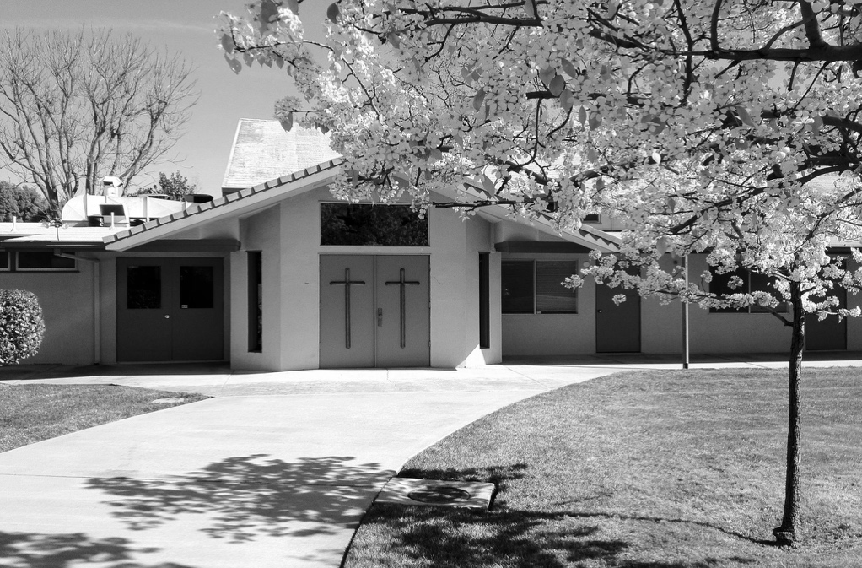*

**THE CALVARY PRESS**

Publication of Calvary Church, 2343 Country Club Blvd, Stockton, California 95204

**What's INSIDE**

2 Board Report

2 Special Offerings

3 Deacon’s Corner

4 Catalyst

5 Calendar

6 Knit Nite news

**Weekly Ministries**

Sunday Worship Service 10:00am

Monday Prayer Night  
7:30-8:30pm

Wednesday Prayer Walk  
2:00-3:00pm

Gratitude for where God has led us this summer. Gratitude at the moments of His visible presence, purpose, promises and peace among us.

The Bible describes numerous occasions where God’s people retreat prior to or after periods of intense work and ministry. These were not always, but quite often mountaintop moments. They were opportunities to look up at all God had done and look out with gratitude at what He was about to do.

Even Jesus had a regular rhythm of mountaintop moments, culminating in the literal experience of God’s presence when Jesus was transfigured in Matthew 17:

***“As the men watched, Jesus’ appearance was transformed so that his face shone like the sun, and his clothes became as white as light … The disciples were terrified and fell face down on the ground.” – Matthew 17:2***

(Continued on page 4)

**AUGUST 2021**

**VOLUME 1 ISSUE 8**

**Equip, Engage and Encourage**

I’ve carved out a few moments to write this letter to you on the week before Vacation Bible School. In just a few short days kids from all over our city will gather at Calvary to press pause on the distractions going on in their lives and press play to the message of truth about Jesus.

This week is the calm before the storm – a rare moment of stillness before the building is transformed into a set with decorations, crafts, games, music, and dancing.

Yet in the week before the energy and excitement of VBS, I’m filled with immense gratitude.

Helpful tip: To practice good stewardship, please return unused offering envelopes and pens to the foyer after worship service on Sunday. Thank you in advance for your stewardship!

**July 2021 Financials**

Income: $25,534.07

Expenses: $18,906.17

Net Income: $6,627.90

(loss)

**Board Member Devotion**

We can see the beauty in God’s creation in nature:   mountains & streams; and it’s the same creation of God all over the world.

We take a lot of things for granted, like the beauty of the earth, modern conveniences and even our daily lives.  We should increase our appreciation for what we have now.

1 Timothy 4:4 — “For everything God created is good, and nothing is to be rejected if it is received with thanksgiving."

**Pastor's Report**

Announcing the Fall Campaign: “*Hero Makers:  Making Heroes of Others.”*

Calvary Press

Page 2

**CALVARY BOARD REPORT**

SPECIAL OFFERINGS

|  |  |  |
| --- | --- | --- |
| **Birthday Fund** |  | **Deacon’s Fund** |
| Charise Masada |  | Jeannie Matsumoto |
| Jim & Sally Tsunekawa |  | Sumi Yonemoto |
|  |  |  |
| **Calvary Press** |  | **In Memory of Sen Akaba** |
| Jeannie Matsumoto |  | Steve & Barbara Takemoto |
|  |  |  |
| **Men’s Breakfast** |  | **In Memory of Katherine Takeko Hayashi-Rowland** |
| Ron & Ilene Kuwahara |  | Ted & Sue Yoneda |
|  |  |  |

**Ways to Give:**

Generosity changes lives! John 3:16 says “God so loved the world that He gave…” Your generosity is living proof that God is still transforming lives today.

To stay up to date on your giving, you can: Complete an offering envelop and mail it back to the church.

**NEW: ONLINE GIVING**

Go to calvarystockton.church/give to set up automatic or one-time giving. It’s a safe, convenient and easy-to-use way to stay up to date on your giving!

* Comfort and peace for Sumi and her family due to the passing of her brother.
* Growth in our faith in Jesus Christ.
* Safety for Sandy's sister and her family in Costa Rica.
* Comfort and prayers for family and friends of David H. who passed away.
* Recovering prayers for Arnie who had a double partial knee replacement.
* Safe travels for Dave's cousins.
* God's comfort and prayers for Ted and Suellen.
* Continued strength and healing for Dorothy.
* Wisdom in helping the homeless.
* For the youth under spiritual attack.

## DEACON’S CORNER

Calvary Press

Page 3

* God's comfort for Roy F.
* God's comfort for family and friends of Dean's friend Ralph who passed away.

Continuous Prayers

* Summer Bowling Ministry.
* Healing for Dan's health and his daughter's cancer.
* For Viet, for his kidney transplant.
* For Joe's continued healing.
* Guidance for the Calvary basketball program.
* Prayers for God's blessings and guidance for Calvary, our Pastor and his family, the congregation, Converge, and all the Christian churches to be a light to the world.
* Revival for our country.

continued on page 6

**MERCY MINISTRY**

Calvary Church has been in need of a program to assist the homeless community. Thanks to Pastor Andrew's vision and past experience, Mercy Ministry was born. The name Mercy Ministry was actually conceived by Pastor Brett Nakashima during one of the weekly staff meetings.

   This idea was presented to the deacons which was whole-heartedly supported. In May, we had numerous members of the congregation come together to volunteer to prepare 25 bag lunches, which we refer to as Mercy Meals. Another group went out to distribute the meals to a number of homeless camps and also to preach God's word.

   In June, we arranged for our second Mercy Ministry in which several volunteers from the congregation came to assemble hygiene kits for our selected homeless camp. Once again, we had several volunteers go out to distribute these Mercy Kits, bottled water and minister God's word as well as sing a number of hymns.

    Not only were we able to nourish the bodies of those in need, but we also nourished their hearts and souls with God's word to our neighbors and most recently, our friends through our Mercy Ministry.

 HOW YOU CAN HELP

   The next time you're out shopping, please keep in mind our homeless community by adding some useful items such as: toothbrushes, dental floss, hand towels, sanitizer, small packages of tissues, hand wipes, etc. You can drop them in our Mercy Supply Box in the social hall.

   We will be preparing 20 meals one month and 20 hygiene kits on the alternate month. Our next Mercy Ministry takes place on Tuesday, August 31st at 2:00 PM. We'll be preparing Mercy Meals in August. If God has reached out His hand to you concerning our Mercy Ministry, we'd love to have you join us. May God's presence and comfort protect those in need. Take care!

* submitted by Dave Furukawa

Calvary Press

Page 4

The last week in July we pressed the pause button on all the noise going on in the life of our kids and pressed play to the message of truth about Jesus. Around 20 kids gathered for this exciting week of fun, games and Bible activities where we learned how to have confidence in Jesus no matter what. Thank you to all who served and gave their time, talents and treasurers to make VBS possible!

VBS

Catalyst Ministry

This past month, Catalyst has had the opportunity to continue meeting on a weekly basis for life groups on Wednesday nights. These life group meetings have been centered around the Word of God and fellowship with one another through inductive Bible studies and sharing meals with one another.

This month we were also able to reach those out of state with the love of Jesus through an online life group meeting. Also, we have begun a study on a book by Dr. Steve Lawson called, “It Will Cost You Everything” based on the standards Jesus sets for his followers in the Gospel of Luke.

Catalyst desires your fervent prayers for a passion to grow within each of its members for Christ and the mission of His Gospel.

* Submitted by Brett Nakashima

This calm before the storm is a mountaintop moment for our church. An opportunity to look up and survey God’s faithfulness over the last few years. But also, an opportunity to thankfully and fearfully cast vision for what He is about to do in the lives of our kids.

We often talk about the vision and mission of Calvary Kids using 3 E’s. Calvary Kids are **EQUIPPED** to know who Jesus is and follow what Jesus says, **ENGAGED** by representing Jesus wherever they go and standing up for Jesus so everyone will know, and **ENCOURAGED** to help others around them and tell others what Jesus has done.

Imagine a day and age where there is no house left where the Gospel and love of Christ hasn’t come. Imagine every child in our community a committed follower of Jesus, able and commissioned to take the Gospel to their school so that more can know about Jesus’ love.

We believe this day is coming in the lives of our children. We believe in faith as we record the testimonies and stories from Vacation Bible School that the foundation for equipping, engaging and encouraging our kids has already started.

Yours in Christ,

Pastor Andrew

## PASTOR’S LETTER (continued from page 1)

Our prayers for God's blessings and guidance for Calvary, our Pastor and his family, the congregation, and Converge and all the Christian churches to be a light to the world. Revival for our country. Prayers that our country returns to following Jesus Christ.

Calvary Press

Page 5

## AUGUST

|  |  |  |  |  |  |  |
| --- | --- | --- | --- | --- | --- | --- |
| SUN | M | T | W | TH | F | SAT |
| 1  **Worship**  **Service:**  10:00am  **VBS Sunday** | 2  **Prayer Night**  7:30pm – 8:30pm | 3 | 4  **Small Group:**  10:00am | 5  Weekly Email Newsletter  **Calvary Bowling**  7:00pm | 6  Office closed | 7 |
| 8  **Worship**  **Service:**  10:00am  **Holy Communion**  Coat Drive Kickoff | 9  **Prayer Night**  7:30pm – 8:30pm | 10 | 11  **Small Group:**  10:00am | 12  Weekly Email Newsletter  **Calvary Bowling**  7:00pm  **Calvary School of Theology**  7:00pm - 9:00pm | 13  Office closed  **Open Gym and Worship Service:**  6:00pm – 9:00pm | 14  **Rummage Sale**  9:00am – 11:00am |
| 15  **Worship**  **Service:**  10:00am | 16  CP Deadline  **UOP Welcome Week**  **Prayer Night**  7:30pm – 8:30pm | 17 | 18  **Small Group:**  10:00am  **Catalyst Life Group:**  7:00pm – 9:00pm | 19  Weekly Email Newsletter  **Calvary Bowling**  7:00pm | 20  Office closed  **Open Gym and Worship Service**  6:00pm – 9:00pm | 21 |
| 22  **Worship**  **Service:**  10:00am | 23  **Prayer Night**  7:30pm – 8:30pm | 24 | 25  **Small Group:**  10:00am  **Catalyst Life Group:**  7:00pm – 9:00pm  CP Mailing | 26  Weekly Email Newsletter  **Calvary Bowling**  7:00pm | 27  Office closed  **Open Gym and Worship Service**  6:00pm – 9:00pm | 28  **Men’s Fellowship Breakfast:**  8:00am – 10:00am  **Financial Seminar:**  **1:00pm-3:00pm** |
| 29  **Worship**  **Service:**  10:00am | 30  **Prayer Night**  7:30pm – 8:30pm | 31  **Mercy Ministry**  2:00pm – 4:00pm | 1  **Alpha Course:**  7:00pm-9:00pm | 2 | 3 | 4 |

**BIBLE**

**C:\Users\SAllyT\AppData\Local\Microsoft\Windows\INetCache\IE\URJRL4DE\120px-Trivia[1].png**

Which city mentioned in Revelation is also an American city?

___________________________________________________

Who was the King that crowned Esther the queen?

____________________________________________________

What happened when the crew threw Jonah overboard?

____________________________________________________

Where was the book of 2 Timothy written?

____________________________________________________

Answers from July’s trivia: his nephew; Felix; Fear; Christ

Page 6

Calvary Press

*Calvary Cares Coat Drive*

# will take place from Now to October 10,  2021

# We will partner with Salvation Army and donate coats to their annual coat giveaway, which will take place on November 5, 2021.

# We welcome new and gently used coats to bless the community.

# Please bring to the social hall coat rack.

# *Luke 3:11 John replied, “If you have two shirts, give one to the poor. If you have food, share it with those who are hungry.”*

*Calvary Rummage Sale*

When: Saturday August 14, 2021, 9am to 11am

Where: Calvary Parking Lot, 2343 Country Club Blvd, Stockton, CA

Donated items accepted each Sunday after church service.



**KNIT NIGHT IS BACK IN SEPTEMBER**

Dust off those bags of yarn!

Break out those crochet hooks and knitting needles!!

Gather all those snacks you are dying to share.

Bring everything to Calvary Church social hall-

Friday, September 10, 2021 and every Friday

6:30pm -9pm

There will be lots of fun, laughter, food and YES knitting!

Now's the time to learn!

There will be FREE yarn, FREE crochet hooks

FREE knitting needles, FREE instruction!!

Come and join the fun!! Looking forward to "hooking" up you!

 **FACILITIES REPORT**

We have so many people to thank this month for taking time out of their month to help update our church:

 Barbara Takemoto and her crew for setting up Sunday School classrooms.

 Mary Nakamura, Sally Tsunekawa ,and Allen Fong for refinishing and painting 5 cabinets for the classrooms.

 Allen Fong and Dr. Kevin Wong for updating our video system for our chapel.

 Dr. Willie and Dr. Gary Low for maintaining the gym and the rental process.

Submitted by Stephen Takemoto

## DEACON’S CORNER (continued from page 3)