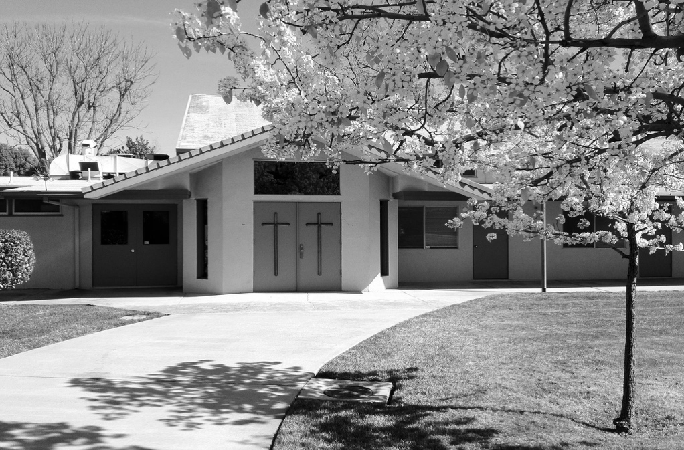

**MAY 2021**

**VOLUME 1 ISSUE 5**

**What Happens at Pentecost**

When the Holy Spirit comes at Pentecost, it is a powerful testimony to the radical change of those first believers. Transformation of not just hearts, but of an entire way of hearing from and experiencing God.

In Acts chapter 2 it says:

‘In those days I will pour out my spirit upon all people. Your sons and daughters will prophesy. Your young men will see visions, and your old men will dream dreams … And I will cause wonders in the heavens above and signs on the path below – blood and fire and clouds of smoke … and everyone who calls on the name of the Lord will be saved.’ (Acts 2:17-21)

If you’re a Christian, you probably know the presence of the Holy Spirit in your life. If you’re filled with the Holy Spirit, it completely changes your outlook on life.

He gives you a set of gifts, an energy, and a joy that’s infectious. The Holy Spirit guides you. He directs you. He convicts you of areas in your life where you aren’t following God and then helps you get back on track. The Holy Spirit is your advocate and your comfort. But if you’ve never really experienced the Holy Spirit, you might be a little bit nervous. For a long time in the church, the Holy Spirit has been ignored. There’s been a much greater concentration on God the Father, God the Son (Jesus), but not so much on God the Holy Spirit. He’s also been misunderstood.

(Continued on page 4)

**What's INSIDE**

2 Board Report

2 Special Offerings

3 Gratitude

3 Deacon’s Corner

3 Facilities Report

4 Pastor’s Letter

5 Calendar

**UPCOMING EVENTS**

**Mom’s Night Out:**

Friday, May 7 from 6:00 to 9:00pm

**Mother’s Day Breakfast:**

Saturday, May 9 from 8:00 to 9:00am

**Marriage Course**

Every Thursday starting

7:00 to 9:00pm

Publication of Calvary Church, 2343 Country Club Blvd, Stockton, California 95204

**THE CALVARY PRESS**

Calvary Press

Page 2

**CALVARY BOARD REPORT**

**March 2021 Financials**

Income: $28,969.33

Expenses: $20,210.72

Net: + $8,758.61

Jesus is our Shepherd; we are His sheep and can be content in Him**.** God provides us with the Holy Spirit for security and hope; and His Word to feed us.  Fix our minds and hearts on Jesus.

Psalm 23:1 “The Lord is My Shepherd, I shall not want.”

Blessed Easter!

-2 services welcomed many first-time adults and children

-Baptism of David Furukawa & Brian Kaneko. Prayers as they took this step of faith & for their continued growth in their faith.

Facilities

-Painting of the church exterior completed

-The restrooms, classrooms & hallway will be painted over the next couple of weeks.

We welcome new Operations Manager, Tiffany Baxter, to Calvary.

First Fruit Offering Update

**Ways to Give:**

Generosity changes lives! John 3:16 says “God so loved the world that He gave…” Your generosity is living proof that God is still transforming lives today.

To stay up to date on your giving, you can:

Complete an offering envelop and mail it back to the church

**NEW: ONLINE GIVING**

Go to calvarystockton.church/give to set up automatic or one-time giving. It’s a safe, convenient and easy-to-use way to stay up to date on your giving!

**In Honor of Brian Kaneko’s Baptism**

Stan & Nancy Kaneko

**In Memory of Katie Komure**

Don & Cindy Shiromizu

|  |  |
| --- | --- |
| **In Memory of Tadashi Agari**  Shirley Bertoni  **In Memory of Miki Kagoshima’s**  **Birthday (4/17)**  Lucy Smits  Ruth Yoneshiga  **Birthday Fund**  Judy Takemoto  Jim & Sally Tsunekawa (Tyler Tsunekawa)  **Deacon’s Fund**  Jim & Sally Tsunekawa  **Masks for the Community**  Stan & Nancy Kaneko  Jerry & Karen Nakamura | **In Memory of Brandon Wehrli** |
| |  | | --- | | Jim & Sally Tsunekawa (Erin’s 2nd birthday) | | Willie & Anna Low  Jerry & Karen Nakamura  Joyce Nakashima  Duane & Jeannie Sakoda  **In Memory of George & Amy Matsumoto**  Janie Low  **In Memory of Katie Komure**   |  | | --- | | L H Nagata | |

|  |
| --- |
| **Easter** |
| Brittany Aoyama  Shirley Bertoni  Daisy Chew  Allen & Myra Fong  Peter & Alice Fong  Trisha Fong  Steve & Barbie Fujinaka  Dave & Sonik Furukawa  Diana Furukawa  Irene Ishida  Dean & Liane Komure  Chris MacDannald  Wallace Pierce  Tim & Hisako Smith  Steve & Barbara Takemoto  Roy & Emily Takeuchi  Gene & Marcy Wong  Kevin & Susan Wong  Ted & Sue Yoneda  Ruth Yoneshige |
|  |
|  |
|  |
|  |
|  |
|  |
|  |
|  |

## SPECIAL OFFERINGS

**BIBLE TRIVIA**

- What did Jesus call the Holy Spirit?

_______________________________

- When was the Holy Spirit first sent to the disciples?

_______________________________

- What symbol is often used to portray the Holy Spirit?

_______________________________

- What are the fruits of the Holy Spirit? (list as many as you can!)

_______________________________

Answers from April’s trivia: John the Baptist, Love God, thorns, four.

|  |  |  |  |  |  |  |
| --- | --- | --- | --- | --- | --- | --- |
| SUN | M | T | W | TH | F | SAT |
| 25  **Worship**  **Service:**  10:00am | 26  **Prayer Night**  7:30pm – 8:30pm | 27  **Small Group:**  7:30pm | 28  CP Mailing    **Small Group:**  10:00am  **Catalyst Life Group:**  7:00pm – 9:00pm | 29  Weekly Email Newsletter  **Marriage Course**  7:00pm – 9:00pm | 30  Office closed | 1 |
| 2  **Communion**  **Worship**  **Service:**  10:00am | 3  **Prayer Night**  7:30pm – 8:30pm | 4  **Small Group:**  7:30pm | 5  **Small Group:**  10:00am  **Catalyst Life Group:**  7:00pm – 9:00pm | 6  Weekly Email Newsletter  **Marriage Course**  7:00pm – 9:00pm | 7  Office closed  **Mom’s Night Out**  6:00pm – 9:00pm  **Open Gym and Worship Service**  6:00pm – 9:00pm | 8 |
| 9  **Mother’s Day**  **Breakfast**  8:00am – 9:00am  **Worship**  **Service:**  10:00am | 10  **Prayer Night**  7:30pm – 8:30pm | 11  **Small Group:**  7:30pm | 12  **Small Group:**  10:00am  **Catalyst Life Group:**  7:00pm – 9:00pm | 13  Weekly Email Newsletter  **Marriage Course**  7:00pm – 9:00pm | 14  Office closed  **Open Gym and Worship Service**  6:00pm – 9:00pm | 15 |
| 16  **Worship**  **Service:**  10:00am | 17  CP Deadline  **Prayer Night**  7:30pm – 8:30pm | 18  **Small Group:**  7:30pm | 19  **Small Group:**  10:00am  **Catalyst Life Group:**  7:00pm – 9:00pm | 20  Weekly Email Newsletter  **Marriage Course**  7:00pm – 9:00pm | 21  Office closed  **Open Gym and Worship Service**  6:00pm – 9:00pm | 22 |
| 23  **Pentecost Sunday**  **Worship**  **Service:**  10:00am | 24  **Prayer Night**  7:30pm – 8:30pm | 25  **Small Group:**  7:30pm | 26  CP Mailing    **Small Group:**  10:00am  **Young Adult Game Night**  6:00pm – 9:00pm | 27  Weekly Email Newsletter  **Marriage Course**  7:00pm – 9:00pm | 28  Office closed  **Open Gym and Worship Service**  6:00pm – 9:00pm | 29  **Men’s Fellowship**  **Breakfast:**  8:00am |
| 30  **Worship**  **Service:**  10:00am | 31  **Memorial Day**  Office Closed  **Prayer Night**  7:30pm – 8:30pm |  |  |  |  |  |

## MAY

Calvary Press

Page 5

Calvary Church

2342 Country Club Blvd

Stockton, California 95204

Non-Profit Organization

U.S. Postage Paid

Stockton, California

Permit No. 161

RETURN SERVICE REQUESTED

We are a welcoming, casual and diverse church in the heart of Stockton’s beautiful Country Club neighborhood. We are a community where you are welcomed whether you are new to faith or a lifelong follower of Jesus.

For more information **call**: 209-466-0221 or **email**: info@calvarystockton.church

Visit our **website**: www.calvarystockton.church or **Facebook**: www.facebook.com/calvarystockton

**Office Hours**: Monday through Thursday from 8:30am to 5:30pm

**Wednesday Prayer Walk**

Every Wednesday

2pm to 3pm

**Small Groups**

Tuesday Night: 7:30pm

Wednesday morning: 10am

Wednesday night: 7pm

Get involved in weekly ministries:

**Worship Service**

Every Sunday

10am to 11am

**Prayer Night**

Every Monday

7:30pm to 8:30pm

**Calvary Church “Centering People in Christ”**

Glory in His holy name; let the hearts of those who seek the LORD rejoice!

Address label

Page 3

Calvary Press

**CAPTURING STORIES OF GRATITUDE**

Help us document God’s faithfulness in your life by sending us a 1-second a day video. This summer, we want to hear your stories of times that you have felt immense gratitude and thankfulness for God’s provision. Setting up and recording your 1-second a day video is simple and easy-to-do. Just record a short 1-5 second video of how God is at work in your life each day. To see a sample to help get you started, go to www.calvarystockton.church/1second. Please email your video submissions to info@calvarystockton.church between now and June 30th. We can’t wait to hear what God has done in your life!

## FACILITIES REPORT

* Richard's daughter, Antonette, is completely recovered from COVID.
* Richard's grandson, Dominic, and wife, Ruthie, gave birth to a baby girl, Emery Menor.
* Kari and Evan Coons (Mike and Janice's daughter and son-in-law) have a new baby girl, Naomi Carmela Coons, born 7 April.
* Healing of Hua's kidney stones.
* Baptism of Brian Kaneko and Dave Furukawa.
* Harold, Ruth Oda's brother passed away.

Comforting prayers for the family.

* Healing for Zoey.
* Emily's friend, that she will join us at Calvary.
* Charise taking COVID vaccine.
* Safety for those administering the vaccine.
* Alex, guidance in farming.
* Norma, guidance of her family.
* Charise's neighbor, Sonia.
* Wisdom in stopping crime.
* Kathy, healing of breast cancer.
* Tim R's grandson, Kaden.
* Oryan's guidance in his college group project and college graduation.
* Continuous prayers for those battling COVID.

## DEACON’S CORNER

Our prayers for God's blessings and guidance for Calvary, our Pastor and his family, the congregation, and Converge and all the Christian churches to be a light to the world. Revival for our country. Prayers that our country returns to following Jesus Christ.

The Facilities Committee would like to thank everyone who contributed to this year’s First Fruit Offering. With our allotment, we have completed the painting of the exterior of the church, and work has begun to paint the restrooms, classrooms, and hallway. If we still have money left over, we will look at replacing the flooring in the Social Hall. A special thank you to our painter, Roy Faulkinbury, who is doing an amazing job! We are still working on getting bids for the replacement of flooring for the Social Hall and meeting area.

Page 4

In the King James Version of the Bible, it talks about ‘the Holy Ghost’, and that sounds a bit weird. Scary: a ghost! Also, he’s been resisted. Some people are a bit nervous about him.

I once heard the story of a very formal church, and they were a bit nervous about the Holy Spirit. One Sunday a woman attended who had just become a Christian, and she’d experienced the Holy Spirit. And in the middle of the service, she shouted out, ‘HALLELUJAH!’ One of the deacons came up to her and tapped her on the shoulder and said, ‘You mustn’t say that here.’ She said, ‘But I’m so excited! I’ve got religion!’ He said, ‘Well, you didn’t get it here, ma’am.’

And that can indeed be the experience of many in the church. When they think of the Holy Spirit, they think an encounter with him must be a dramatic and strange experience. Certainly, the Holy Spirit has worked that way and continues to work that way today. However, most of the time the Holy Spirit works in a different way. In the every day.

When the Holy Spirit was poured out on the believers at Pentecost, it wasn’t a weird or foreign experience. It was sudden and startling, but it was marked by the real presence of God – and out of that experience came a multitude of gifts. Gifts like prophecy, speaking in tongues, and spiritual discernment. From that point forward, these gifts became part of their everyday experience of God.

We believe for you, part of the year of provision is experiencing the presence of the Holy Spirit in a tangible and significant way in your day-to-day life. Through spiritual gifts, revelation, overcoming sin, and so many more radical transformations. The truth is, God wants to transform your life today, and He’s at work doing that through the power of His Holy Spirit.

As we approach Pentecost Sunday on May 23, my prayer for you is that you’ll encounter the Holy Spirit in your life - not just through coming to church and experiencing the Holy Spirit in a dramatic way, but also through real transformation in your day-to-day life.

Yours in Christ,

Pastor Andrew

**For more encouraging devotionals**

Go to our website ***www.calvarystockton.church/blog*** for a new devotionals every Wednesday.

It’s a great way to get uplifted and to be filled with the Holy Spirit during the week!

Calvary Press

Page 4

## (continued from page 1)