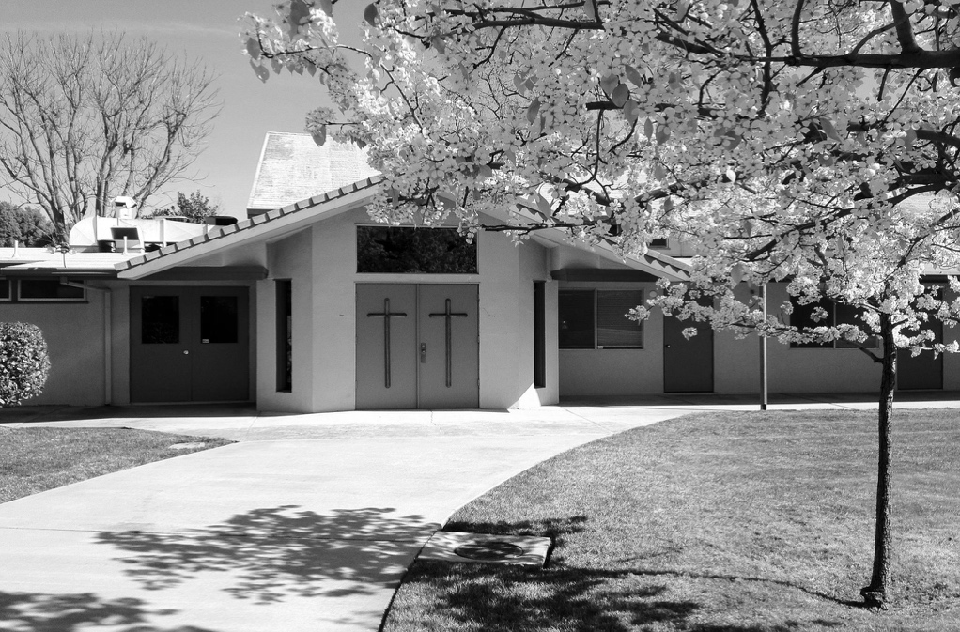

**JUNE 2021**

**VOLUME 1 ISSUE 6**

*

Publication of Calvary Church, 2343 Country Club Blvd, Stockton, California 95204

the words of this poem again come to the forefront of my mind. Hezekiah was a person who, because he understood the source of his provision, was able to respond with immense gratitude.

Gratitude that was not based on his circumstances (his failing health), but on the presence of God’s hand in his life.

Today we define gratitude by our varying levels of thankfulness. If I have much, I am thankful and therefore deeply grateful. If I have little, I might not have much to be thankful for and usually I am resentful.

But what if this Summer you were challenged to rethink that idea? What if gratitude isn’t about having, getting, borrowing, or receiving, but instead about experiencing God’s presence?

(Continued on page 4)

Hezekiah breaks down in tears, devastated to learn his days are numbered. And in a strange turn of events, God hears his prayer and adds 15 years to his life!

Imagine receiving such awful news, followed by the promise of an additional decade added to your life – being filled with sorrow, followed by relief and joy.

Hezekiah felt immense gratitude. After, he writes a beautiful poem in Isaiah 38:15-17:

*But what could I say? For he himself sent this sickness. Now I will walk humbly throughout my years because of this anguish I have felt. Lord, your discipline is good, for it leads to life and health. You restore my health and allow me to live! Yes, this anguish was good for me, for you have rescued me from death and forgiven all my sins.*

As we’ve been praying for the guiding word for this Summer,

**The Summer of Gratitude**

We start each Summer at Calvary be asking God to give us a guiding word for the church. As I’ve planned and prayed, God continued to bring one passage to the front of my mind from Isaiah 38.

Hezekiah, who was the king of Israel and a God-fearing and holy man fell ill. The prophet for the nation at that time, Isaiah, approaches the king with the unfortunate news that he won’t recover from this sickness.

**THE CALVARY PRESS**

Calvary Press

Page 2

**CALVARY BOARD REPORT**

**Board Member Devotion**

It can be helpful to use this acronym when talking with God:

**P**repare: let God know what’s going on in your life.

**R**equest: direct God’s energy for your needs & needs of others. Be

specific.

**A**ffirm: prayer is energy; reinforce, reaffirm, remind ourselves.

**Y**ield to God’s answers. He answers all prayers; not always what we

want to hear; surrender to God’s answer & to what God

knows is right.

Calvary Church will host a free San Joaquin County pop-up COVID testing & vaccination clinic. It is organized by director Joan Singson and partnered with Madison School. It will be held in the Calvary gym in June for our community (no volunteers are needed, they are fully staffed).

**March 2021 Financials**

Income: $20,031.58

Expenses: $20,806.44

Net Income - $774.86

(loss)

## SPECIAL OFFERINGS

## FACILITIES REPORT

A huge thank you to our painter Roy Faulkenbury who Is currently completing the painting of our classrooms. The committee is still exploring the updating of the flooring in the Social Hall and classrooms. Please pray for the committee and our updating ideas for Calvary.

- Submitted by Stephen Takemoto

**Birthday Fund**

Janice Ishimaru

Jim & Sally Tsunekawa (Steven & Trinity)

Helpful tip: To practice good stewardship, please return unused offering envelopes and pens to the foyer after worship service on Sunday. Thank you in advance for your stewardship!

**Ways to Give:**

Generosity changes lives! John 3:16 says “God so loved the world that He gave…” Your generosity is living proof that God is still transforming lives today.

To stay up to date on your giving, you can: Complete an offering envelop and mail it back to the church.

**NEW: ONLINE GIVING**

Go to calvarystockton.church/give to set up automatic or one-time giving. It’s a safe, convenient and easy-to-use way to stay up to date on your giving!

|  |  |  |  |  |  |  |
| --- | --- | --- | --- | --- | --- | --- |
| SUN | M | T | W | TH | F | SAT |
| 30  **Worship**  **Service:**  10:00am | 31  **Memorial Day**  Office Closed  **Prayer Night**  7:30pm – 8:30pm | 1  **Small Group:**  7:30pm | 2  CP Mailing    **Small Group:**  10:00am  **Young Adult Game Night:**  7:00pm – 9:00pm | 3  Weekly Email Newsletter | 4  Office closed | 5 |
| 6  **Holy Communion**  **Worship**  **Service – Kickoff of Summer of Gratitude:**  10:00am  **Evangelism**  **Training:**  1:00pm – 3:30pm | 7  **Prayer Night**  7:30pm – 8:30pm | 8  **Small Group:**  7:30pm | 9  **Small Group:**  10:00am  **Catalyst Life Group:**  7:00pm – 9:00pm | 10  Weekly Email Newsletter | 11  Office closed  **Open Gym and Worship Service**  6:00pm – 9:00pm | 12 |
| 13  **Worship**  **Service - Invite a**  **Friend Sunday:**  10:00am | 14  **Prayer Night**  7:30pm – 8:30pm | 15  **Small Group:**  7:30pm | 16  **Small Group:**  10:00am  **Catalyst Life Group:**  7:00pm – 9:00pm  **Calvary School of Theology:**  7:00pm – 9:00pm | 17  Weekly Email Newsletter | 18  Office closed  **Open Gym and Worship Service**  6:00pm – 9:00pm | 19  **Dad’s Day Out** |
| 20  **Father’s Day**  **Breakfast:**  8:30am – 9:30am  **Worship**  **Service:**  10:00am | 21  CP Deadline  **Prayer Night**  7:30pm – 8:30pm | 22  **Small Group:**  7:30pm | 23  **Small Group:**  10:00am  **Catalyst Life Group:**  7:00pm – 9:00pm | 24  Weekly Email Newsletter | 25  Office closed  **Open Gym and Worship Service**  6:00pm – 9:00pm | 26  **Men’s Fellowship Breakfast:**  8:00am – 10:00am |
| 27  **Worship**  **Service:**  10:00am | 28  **Prayer Night**  7:30pm – 8:30pm | 29  **Small Group:**  7:30pm | 30  CP Mailing    **Small Group:**  10:00am  **Young Adult Game Night**  6:00pm – 9:00pm | 1  **Stockton Ports Game Night** | 2 | 3 |

## JUNE

**BIBLE TRIVIA**

- What is the name of the well that Abraham and Abimelech quarrel over? _______________________________

- In the Song of Songs, how much is the bride’s dowry?

_______________________________

- Who is David’s chief counselor?

________________________________

- In 2 Samuel 14, how did the wise woman disguise herself?

_______________________________

Answers from May’s trivia: Advocate, Pentecost, dove, see Gal. 5:22-23

Calvary Press

Page 5

Calvary Church

2343 Country Club Blvd

Stockton, California 95204

Non-Profit Organization

U.S. Postage Paid

Stockton, California

Permit No. 161



**LOOK INSIDE:**

* Pastor Andrew offers thoughts about Gratitude
* Donation Opportunities from the Deacons
* Catalyst Life Group Update…. And more!

**phone:** 209-466-0221 **email**: [info@calvarystockton.church](mailto:info@calvarystockton.church) **website**: www.calvarystockton.church

Reach out to others and

**Invite a Friend Sunday**

**and Ports Ticket Giveaway!**

Sunday, June 13

10:00am – 11:15am

Enjoy fun, fellowship,

and food at the

**Father’s Day Breakfast**

Sunday, June 20

8:30 – 9:30am

and

**Dad’s Day Out**

Saturday, June 19

Learn how to effectively

share your faith at the

**Evangelism Training Course**

Sunday, June 6

1:00 – 3:30pm

Learn about the Theology of

Language and Science at the

**Calvary School of Theology**

Wednesday, June 16

7:00 – 9:00pm

**COMING UP @ CALVARY**

Don’t miss these exciting events! More information is available online and in service.

RETURN SERVICE REQUESTED

Address label

Page 3

Calvary Press

## DEACON’S CORNER

* Sandy, healing of her elbow.
* Boon's daughter hospitalized due to COVID.
* Healing prayers for John Newitt (motorcycle accident).
* Larry, diabetes complications.
* God's guidance for Mariava's job search.
* For the leaders of our country, faith that they will turn their lives over to Christ.
* The ministry serving the homeless. May they turn their lives over to Christ.
* Healing prayers for Steve's recovery.
* Prayers for Oryan and guidance for his college group project and graduation.
* Continuous prayers for those battling COVID.
* Thanks to God for Ron's visitation to his mom.
* Prayers for all graduates.
* Barbara gives thanks to God for Steve's recovery and the congregation's Prayer support.
* Graduation of Shannen, Gordon and Oryan.
* Thank you, Lord, for your sacrificial love for this world.
* Healing prayers for Kathy Oda.
* Healing prayers for Janice and Trisha.
* Comforting prayers for Officer Inn's Family.
* Ron, healing of his ankle.

1. Tooth brushes
2. Tooth Paste
3. Dental Floss
4. Small bottles of shampoo
5. Small soaps
6. Neosporin
7. Band Aids
8. Small packets of Kleenex
9. Blankets
10. Tampons
11. First aid tape
12. Small writing tablets
13. Boxes of pens
14. Tooth picks
15. Nail clippers
16. Wooden nail files
17. Small bottles of sanitizers
18. Baby wipes
19. Small wash cloths
20. Towels

**Donation Opportunities!**

The Deacons are continuing the **Toiletry Ministry**. Personal hygiene items, such as soap, shampoo, lotion, toothbrushes, and toothpaste can be placed in the bin located in the Fellowship Hall. These items are donated to the Stockton Shelter for the homeless, Gospel Center Rescue Mission and Salvation Army.

Last month, our wonderful group of volunteers assembled 25 hearty lunches plus bottles of water for our first **Mercy Ministry**. Pastor Andrew and I discussed this ministry in depth and not only did we want to nourish the bodies of the needy, but we also want to nourish their souls as well. So we plan to spend one month preparing meals and the alternate month assembling hygiene and supply kits as well as praying for those in need, singing hymns and listening to their stories.

On Tuesday, June 29TH, we will be looking for volunteers to help assemble Mercy kits. We plan to prepare 25 of these kits from 2:00 to 3:00pm. The kits will be distributed from 3:00 to 4:00pm. Everyone is welcome to join us or offer their support.

For those of you who would like to assist, but are unable to attend, you can help by donating the **items listed to the right**. Blessings to all.

* submitted by Dave Furukawa

Our prayers for God's blessings and guidance for Calvary, Pastor Andrew's family, the congregation and Converge. May all Christian churches be the light to the world. Prayers that our country returns to following Jesus.

Our prayers for God's blessings and guidance for Calvary, our Pastor and his family, the congregation, and Converge and all the Christian churches to be a light to the world. Revival for our country. Prayers that our country returns to following Jesus Christ.

*Young Adult Game Night in May*

This past month, Catalyst has begun a gradual process of moving back into in-person ministry events by alternating weekly between online and in-person meetings for Life Group. We have been graced with the opportunity to continually reach people outside of the city of Stockton with our online meetings and have members of our ministry joining online from Southern California each week. We most recently finished an Inductive Bible study series through the different miracles recorded throughout the Bible and are continuing in our Inductive studies in the book of Psalms. We also were able to have our monthly Catalyst game night in-person and were able to meet 4 new guests through the event. As we look forward to all of the events planned for the summer, we move forward with trust in God’s faithfulness and we ask for your fervent prayers that the LORD would make this upcoming season a transformational and formative one for those within our young adult ministry and those we hope to reach with the Gospel of Christ.

* Submitted by Brett Nakashima

## CATALYST LIFE GROUP UPDATE

The Summer of Gratitude at Calvary is about knowing the source of your provision and experiencing the presence of God in your life. For Hezekiah it didn’t matter if he was in good health or poor. Simply having God with him was enough for him to respond with gratitude.

This Summer, I want to invite you to experience God in the same way. To know that whatever situation you face – poor or good health, much or little in the bank, friends or no friends, grief or no grief – you can still respond in gratitude when you experience God’s presence in your life.

This message is more important for our world now than ever before, since increasingly people are fighting and dividing themselves over who has and hasn’t, or who is thankful and who doesn’t have much to be thankful for.

So I also want to challenge you to make it your number one priority to invite your friends, family and those you know to experience this Summer of Gratitude for themselves by inviting people to attend one of our services (the series on gratitude begins June 6) and being intentional about sharing the hope of Jesus with those around you.

Yours in Christ,

Pastor Andrew

**For more encouraging devotionals**

Go to our website ***www.calvarystockton.church/blog*** for a new devotional every Thursday.

It’s a great way to get uplifted and to be filled with the Holy Spirit during the week!

Calvary Press

Page 4

## (continued from page 1)