Calvary Presbyterian Church Non-Profit Organization
2343 Country Club Blvd. U.S. Postage Paid
Stockton, CA 95204 Stockton, California
Permit No. 161

RETURN SERVICE REQUESTED

Pastor’s Introduction

“So now you Gentiles are no longer strangers and foreigners. You are citizens along with all of God’s holy people.” – Ephesians 2:19 (NLT)

Have you ever been the “newbie” in a place – maybe because you joined a club, moved to a different city, or got a new job? Maybe it was difficult at first to adapt to the new culture you found yourself in, and you struggled to fit in. You had to try new things at first—things which put you slightly out of your comfort zone.

Yet over time, you adapted and found a new identity in that place. You moved from ‘newbie’ to trusted member, new hire to colleague, immigrant to citizen. You finally felt like you were part of the group.

As Christians, we’ve always had a curious identity in the places we live. From the beginning of the early church, it was the Christians who found themselves the ‘newbies’ and strangers. They were persecuted for their faith for hundreds of years under the Roman empire. Even today, the Christian church continues to thrive underground in the Middle East and Asia, despite intense persecution.

And perhaps you’ve felt like a stranger as a follower of Jesus. You had to explain to your friends, who aren’t Christians, why you don’t go out and party with them on the weekends. You don’t contribute to the gossip mill at work, even though everyone around you spreads news about each other every day. You turned down that shady deal, because you follow a different set of business ethics.

Christians are strangers, foreigners, wanderers, and yes—newbies. Yet, strangely, this is a beautiful picture of what it means to be a follower of Jesus. You’re set apart, never entirely part of the place you find yourself. Because you follow a different set of rules and a different way of living.

Ephesians says, as followers of Jesus, we’re citizens of a different kingdom. It’s a kingdom not defined by your background, race, socioeconomic status, or family history. Instead, your belonging to this kingdom is determined by one thing. Are you a follower of Jesus?

As your new pastor, it would be easy for me to assume that I’m a ‘newbie’ to the Calvary family. One day, I might feel like an insider—like I belong. But not so, because I’m reminded of the promises of Ephesians. We belong together as citizens of a new kingdom. And while it’s true that we’ll continue growing closer in our friendships as we journey together, we’re already united in a way that no nationality, club or organization can offer. We’re brothers and sisters in Christ. We are no longer strangers or foreigners, but a family united by our citizenship in God’s kingdom.

The name attached to this kinship—be it unity in the Holy Spirit, being brothers and sisters in Christ, etc.—confers on us all the traditions and expectations of being family. I’ve already experienced that in an incredible way. I can’t thank you enough for the welcome you’ve extended to us during our transition to Stockton. From the meals, to the encouraging notes, to the small favors—you’ve embodied what it means to be a family of Christ.

And I look forward to the future traditions we will enjoy. I can’t wait to share meals around a table, spend time together, laugh and enjoy each other’s company. But most of all, I look forward to seeing our family grow, as more people become brothers and sisters along with us in God’s Kingdom.

Yours in Christ,
Pastor Andrew

You Are Not Alone!

Your church family is here for you during this unprecedented time in our nation and world. At Calvary we always been known for our ability to pull together when something needs to get done. With the direction and oversight of Pastor Andrew Phillips, your church leaders have been working on keeping us connected and rooted in Christ.

Leaders have made the commitment to stay in regular contact with every member and friend of our church to keep them informed about resources for Bible study, videoconferencing, devotions, and prayer groups. If you have not been contacted please let us know by connecting with Brian in the office (209.466.0221 or email info@cpcstockton.org), Pastor Andrew (pastor@cpcstockton.org) or any Elder or Deacon.

As we resume in-person services in July, pleae continue to check the church website (www.cpcstockton.org) and Facebook page (www.facebook.com/calvarystockton) for information.

Remember that the church is not a building, rather it is the people who make up the church. That’s you. So even as we resume in person services and continue to have live streamed services, we are still the church and you are still part of it – whether you worship with us online or in person.

June 1 Pastor Andrew’s first day as Lead Pastor of Calvary.
June 21 Calvary reopened for our first in-person Worship Service since March 15. The service was also streamed online. Up to this point we had been having weekly Leadership Meetings & the Sunday Worship Service on Zoom.

Facilities: The Church facility was “deep cleaned” by Clark Pest Control Essential Clean disinfecting service. All necessary precautions per CDC were put in place for safe distancing & a touchless service. The foyer to the Chapel was repaired.
In the gym: Duct work, Smoke detectors & complete service done.

May Financials 2020
Income: $24,307.77
Expenses: $16,657.91
Net: $ 7,649.86

So, we are Christ’s ambassadors; God is making His appeal through us. We speak for Christ when we plead, “Come back to God!” - 2 Corinthians 5:20

Deacon’s Corner
Deacon’s on-going Outreach Project: Toiletry collection and canned food drive.

We are asking healing prayers for Reverend Saburo Masada and Ruth Oda.

A special thanks to the ladies at Calvary who have donated their time, talent and money in designing over 3100 masks. These face coverings have been distributed to numerous hospitals and other organizations throughout the state.

The congregation would to acknowledge and congratulate our 2020 college graduates:
1. Shivani Bhatt
2. Christopher Low
3. Katelyn Nakamura
4. Brett Nakashima
5. Scott Sakoda

We would like to thank and recognize Sally Tsunekawa for the awesome 2020 graduation slide show. Nobody does it better than Sally.

A special thanks must go out to Jerry and Karen Nakamura for extending their warm hospitality to the Phillips family. They invited the Phillips to rent their home and made the move from New York City to Stockton a smooth transition for Pastor Andrew and his family.

Our deepest condolences to the family of the late Kevin Wong. May God comfort you during this time of sorrow.

Dean and Liane's daughter Roxanne and son-in-law Mark gave birth to a baby boy, Ivan George Biles 7 lbs. 10 oz. Congratulations from all of us!

Pastor and Mariava have announced Joshua will be expecting a baby sister this October. Your prayers have been answered. Congratulations to the Phillips family!

Finally, the congregation would like to extend a well-deserved retirement to Jeannie Sakoda. Jeannie has spent 42 years as an occupational therapist with 31 years employed at St. Joseph's Hospital. The next stage of your life is about to begin, best of luck, Jeannie!

"But I pray you, O Lord, in the time of your favor, in your great Love, O God, answer me with your salvation. - Psalm 69:13
Many have asked how you can to continue to support Calvary with offerings and tithes while we are not meeting in person. Please mail your offerings to the church at 2343 Country Club Blvd., Stockton, CA 95204. Thank you for your continued support and God bless you!

Church Facilities Report for June
Members of the facilities committee have been very busy this month getting ready for our first
in-person Sunday service which happened on June 21. The ceiling in the entry way to the chapel was replaced and new lights were installed. All classrooms were cleaned and straighten up, the storage area behind the sanctuary was reorganized and the kitchen was cleaned and also reorganized too. The facilities committee also contacted Clark Pest Company to professionally clean and sanitize the entire church on June 15, prior to our in-person opening on June 21. Submitted by Stephen Takemoto.

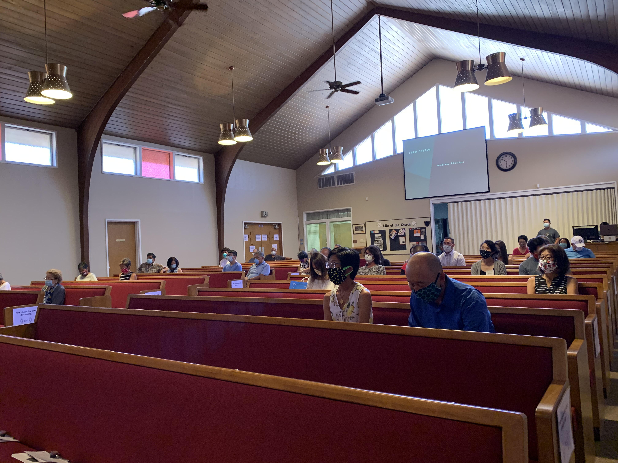
Church Resumes In-Person Services
Calvary resumed its in-person services on Sunday, June 21, and had more people join us than we expected. It was such a blessing to be able to worship in-person together as a church family. Having our service remain online has been a blessing as well. I want to thank those of you who helped prep and clean the church beforehand. Your hard work and dedication doesn’t go unnoticed. We have such an awesome leadership at Calvary and congregation. This wouldn’t be possible without the help and guidance of our new lead pastor, Andrew Phillips. He has been such a huge contribution to our church and being able to work along side him is great. We know that God is good all the time and He will be with us every step of the way. We are still living in an unprecedented time, but with God by our side, we are protected and well-cared for, amen! Submitted by Brian Kaneko.

Special Offerings

Memorial Day | Masks for our Community
Aiko Aoyama | Jerry & Karen Nakamura
Janice Ishimaru | Ken & Karen Natsuhara
Mary Lam
 | Birthday Fund
In Memory of Kyo & Paul Sato | Janice Ishimaru
Grace Sato | Jim & Sally Tsunekawa (Nate Tsunekawa)
Deacon’s Fund | Easter
Ted & Sue Yoneda | Charise Masada

July 2020
Sunday | Monday | Tuesday | Wednesday | Thursday | Friday | Saturday
28  In-person service  and online:  10:00am | 29  Daily Devotional | 30  Daily Devotional  Evangelism  mini-course:  7:00pm | 1  Weekly update | 2  This Sunday @ Calvary! | 3  Office closed | 4
5  Summer of Psalms  kickoff!  In-person service  and online:  10:00am | 6 | 7 | 8  Weekly update | 9  This Sunday @ Calvary! | 10  Office closed | 11
12  In-person service  and online:  10:00am | 13 | 14 | 15  Weekly update | 16  This Sunday @ Calvary! | 17  Office closed | 18
19  In-person service  and online:  10:00am  Membership class:  2:00-4:30pm | 20 | 21  CP Deadline | 22  Weekly update | 23  This Sunday @ Calvary! | 24  Office closed | 25
26  In-person service  and online:  10:00am | 27 | 28 | 29  CP Mailing  Weekly update | 30  This Sunday @ Calvary! | 31  Office closed | 1
Church office hours: Monday – Thursday: 8:30 am – 5:30 pm

