MARCH 2021
VOLUME 3 ISSUE 3

What's INSIDE
2 Board Report
2 Deacon's Corner
2 Catalyst
3 Update on Giving
4 Special Offerings
5 Pastor’s letter
6 Calendar
UPCOMING EVENTS
Men’s Fellowship Breakfast:
Saturday, March 6 & 27 from 8:00 to 10:00am

Evangelism Training:
Sunday, March 7 from 1:00 to 3:30pm

Calvary Big Trees Family Day Out:
Saturday, March 13 from
10:00 to 3:00pm
The Sunday Before Easter

He was in trouble, and I didn’t know the phone number for an ambulance!
Now, before you jump to conclusions that your pastor doesn’t know how to dial 9-1-1, let me explain.
We had just moved to the United Kingdom as missionaries, and contrary to what you might think, 9-1-1 is not the universal phone number for emergency services around the world.
I was out in the evening through a neighborhood chaplaincy ministry, and came across a homeless man who was stooped over on the side of the street. He was in bad shape, within inches of his life. And why hadn’t I thought to learn the phone number for 9-1-1 before moving to a new country!?

Publication of Calvary Church, 2343 Country Club Blvd, Stockton, California 95204
THE CALVARY PRESS
The Sunday before Easter, Jesus rides into Jerusalem on the back of a horse while crowds of people lay palm branches and coats at his feet. It was an entry only fit for royalty. This man, ridiculed and mocked throughout his entire ministry by religious leaders and crowds, is suddenly welcomed as a triumphant king.

(Continued on page 6)

Calvary Press
Page 2
CALVARY BOARD REPORT

January 2021 Financials

Income: $25,521.80

Expenses: $14,766.69

Net: +$10,755.11

Officers of the Board Elected

Chair: Pastor Andrew Phillips
Vice-Chair: Steve Takemoto
Secretary: Joyce Nakashima (not Board Member)
Co-Treasurers: Sally Tsunekawa & Myra Fong
*Background checks will be conducted by Converge for all present Board members, Elders, Deacon members, church staff, persons handling finance, and persons working with children, youth and vulnerable adults. This policy will be applicable to all persons joining these groups.

DEACON’S CORNER

For the month of February, Catalyst has been in a continual season of meeting online for weekly Inductive Bible Studies through the Gospel of John. Through these weekly meetings online, we’ve been able to reach people both within and outside of Stockton with the truth of God’s Word. The start of the new year also means the start of a new season of seeking the LORD and His guidance. The way we’ve been actively living this out is through a 29-Day Prayer Burn where every day from 6:30AM-7:30AM we join in together online in prayer. Through the advantages of online meetings, we’ve been able to reach people across our state as well as out of state with these prayer meetings. God has clearly been at work throughout these meetings in answered prayers and new-found hunger for the LORD. As we look forward to the upcoming months, we ask for continued prayers that Catalyst would be able to continue to seek the LORD’s presence continually alongside one another.

Pastor’s Report:
-The Supreme Court overturned ban on indoor worship last week, but for now, Calvary will continue outdoor worship services while weather is good.
-Two Easter Sunday worship services: 11am & 1pm

CATALYST LIFE GROUP

- Healing prayers for Jeannie’s friend, Cathy,
- who has COVID.
- Healing prayers for Shivani’s injured back.
- Healing prayers for Barbara’s Uncle Ted and Uncle Jim.
- Prayers for Brandon Blakemore who is suffering from depression.
- Prayers for Dean’s friend, Bob, who is moving to Mexico.

PRAYER REQUESTS:
- Blessing to Brandon McMinn for acceptance into physical therapy program.
- Blessings on Oryan’s job search.
- Healing prayers for Brian Dwyer who has COVID.
- Healing prayers for Brian Dwyer’s
father-in-law who has COVID.
- Healing prayers for Charise’s neighbor whose son passed away.

The Facilities Committee would like to thank Dean Komure, Gary Nakashima, Steve Takemoto and Pastor Andrew for constructing the new pallet backdrop for our Sunday services. The committee would also like to thank everyone that contributed to this year’s “First Fruit Offering”. We are using our portion to start updating our restrooms and possibly updating the social hall flooring if enough money is collected. Also, a special thanks to Ron Kuwahara and Dean Komure for cleaning the gutters by the gym.

Submitted by,
Steve Takemoto

BIBLE TRIVIA ANSWERS FROM LAST MONTH: Bethlehem, 27, 5,000 people, Peter

FACILITIES REPORT

Members and friends of Calvary - please use the enclosed offering envelope for your Easter offering. Bless you for your continued support of Calvary!

MARCH

SUN | M | T | W | TH | F | SAT
31  Worship  Service:  10:00am | 1  Prayer Night  7:30pm – 8:30pm | 2  Small Group:  7:30pm | 3  Pastor’s Devotion  Small Group:  10:00am  Catalyst Life Group:  7:00pm – 9:00pm | 4  Weekly Email Newsletter | 5  Office closed | 6  Men’s Fellowship  Breakfast:  8:00am
7  Communion  Worship  Service:  10:00am  Evangelism  Training:  1:00pm – 3:30pm | 8  Prayer Night  7:30pm – 8:30pm | 9  Small Group:  7:30pm | 10  Pastor’s Devotion  Small Group:  10:00am  Catalyst Life Group:  7:00pm – 9:00pm | 11  Weekly Email Newsletter | 12  Office closed | 13  Calvary Big Trees Family Day Out:  10:00am – 3:00pm
14  Worship  Service:  10:00am | 15  Prayer Night  7:30pm – 8:30pm | 16  Small Group:  7:30pm | 17  Pastor’s Devotion  Small Group:  10:00am  Catalyst Life Group:  7:00pm – 9:00pm | 18  Weekly Email Newsletter | 19  Office closed | 20
21  Worship  Service:  10:00am | 22  CP Deadline  Prayer Night  7:30pm – 8:30pm | 23  Small Group:  7:30pm | 24  Pastor’s Devotion  Small Group:  10:00am  Catalyst Life Group:  7:00pm – 9:00pm | 25  Weekly Email Newsletter | 26  Office closed | 27  Men’s Fellowship  Breakfast:  8:00am
28  Worship  Service:  10:00am | 29  Prayer Night  7:30pm – 8:30pm | 30  Small Group:  7:30pm | 31  Pastor’s Devotion  CP Mailing  Small Group:  10:00am  Catalyst Life Group:  7:00pm – 9:00pm | 1  Weekly Email Newsletter | 2  Office closed  Good Friday (Stations of the Cross) Service:  1:00pm – 4:00pm | 3

Calvary Press
Page 6
Non-Profit Organization
U.S. Postage Paid
Stockton, California
Permit No. 161

Calvary Church
2342 Country Club Blvd
Stockton, California 95204

We are a welcoming, casual and diverse church in the heart of Stockton’s beautiful Country Club neighborhood. We are a community where you are welcomed whether you are new to faith or a lifelong follower of Jesus.

For more information call: 209-466-0221 or email: info@calvarystockton.church
Visit our website: www.calvarystockton.church or Facebook: www.facebook.com/calvarystockton

Office Hours: Monday through Thursday from 8:30am to 5:30pm

Wednesday Prayer Walk
Every Wednesday
2pm to 3pm

Small Groups
Tuesday Night: 7:30pm
Wednesday morning: 10am
Wednesday night: 7pm
Get involved in weekly ministries:
Worship service
Every Sunday
10am to 11am

Prayer Night
Every Monday
7:30pm to 8:30pm

Calvary Church “Centering People in Christ”

RETURN SERVICE REQUESTED

Glory in His holy name; let the hearts of those who seek the LORD rejoice!

Address label

Page 3
Calvary Press

NEW ONLINE AND RECURRING GIVING OPTION

GO TO: www.calvarystockton.church/give to set up giving online
You can now make your regular tithes and offerings through
credit/debit card, either online through our website or by
filling out an offering envelope! To get started with card
giving today, simply fill out an offering envelope with your
card details and return it to the church office, or go to
www.calvarystockton.church/give to set up your gift straight
away. We encourage you to give online so you can
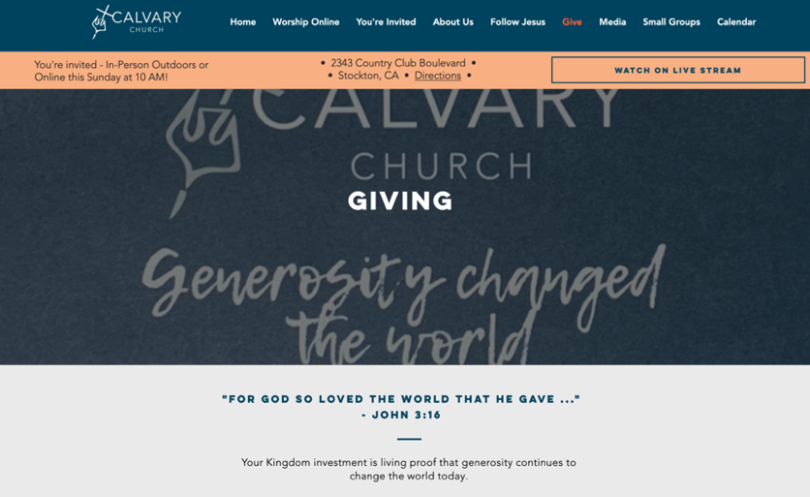
automate your tithe or offering by having it automatically be taken from your card. You can select weekly, bi-weekly or monthly giving in any amount and on any day of the month. It’s a safe, convenient and secure way to make sure you stay up to date on your giving and honor God with your finances. Plus, through setting up a giving account online, you get immediate access to your giving history and tax-deductible receipts.
FAQ
Is there a processing fee for my gift?
Yes. We partnered with an industry-leading
card processing company that offers the lowest
processing rate in the industry for churches.
However, to ensure your full amount goes to
The church you can offset the card processing
charge. For online giving, just click the box
labelled “Increase my donation to $_______
to cover the transaction fee.” If you’re giving by
card through envelope, simply increase your gift by 3% (Example - $100, increase gift to $103; $50, increase gift to $51.50).
Is it safe?
Yes. The company that processes the cards is used by churches across the world, as well as by large Fortune 500 companies including Amazon and Google.
Do you store my card information?
No. For online giving we never even see your card details. All information is stored directly by the card processor using industry-leading encryption. For card information on offering envelopes, we immediately shred the envelop after processing your gift. Card details on envelopes are only seen by the Calvary treasurer(s).

Calvary Press
Jeannie Matsumoto
Birthday Fund
Sumi Yonemoto
Deacon’s Fund
Janice Ishimaru
Ted & Sue Yoneda

Mary Hirose’s 100th Birthday
Mari Fitch
In Memory of Gary Ishimaru
Janice Ishimaru
In Memory of Tadashi Agari
Jeannie Matsumoto
Joyce Nakashima
Tak & Linda Saito

In Memory of Brandon Wehrli
Willie & Anna Low
Jerry & Karen Nakamura
Joyce Nakashima
Duane & Jeannie Sakoda
In Memory of George & Amy Matsumoto
Janie Low
In Memory of Katie Komure
L H Nagata

SPECIAL OFFERINGS

Page 4

Calvary Press
Page 5
Like deciding to learn the emergency services number when it’s too late, people often turn to God when there is something they desperately need. Church attendance goes up after major crisis. People pray for God’s help when they hit rock bottom. The crowd turns to Jesus, shouting – “we didn’t want you to be our king before, but now we need you! Come Jesus! Help!”
And in those moments, we expect Jesus to answer our cry for help in the way we want. Jesus, fix my broken marriage. Jesus, pay my medical bill. Jesus, help me remember the number for 9-1-1!
But on that Sunday before Easter, the answer the crowd was looking for wasn’t the answer Jesus was providing. They were searching for a triumphant king to save them, but the kind of salvation Jesus would bring was that of a suffering Messiah. They expected a great political and military leader, but Jesus would soon be crucified on a cross with even his closest followers abandoning him.
The moments when you search for God, but receive an answer that doesn’t match your expectations, can often be disappointing. But you must know that, however disappointed you may feel, the answer God provides is always for your benefit. When you ask for something at a surface level, Jesus answers in a way that will satisfy your deepest longings.

For more encouraging devotionals
Go to our website www.calvarystockton.church/blog for a new devotionals every Wednesday.
It’s a great way to get uplifted and to be filled with the Holy Spirit during the week!

And so too for the crowd. Disappointed as they were at the events that would transpire in the coming week, they learn the meaning of the true kingdom that Jesus was bringing. A kingdom not intended to save them from the political problems they were facing, but one that would save their souls.
On the Sunday before Easter, they were asking for something superficial. But the next Sunday, Easter Sunday, Jesus would give them something that would save them at the deepest level.
And this Easter season, Jesus is offering you the same answer. In the moments when you ask for his provision, he wants to provide you the greatest gift of all. The gift of new life, redemption, and restoration.
Sometimes, like for the crowd, it simply requires you to reframe how you see him. Is he a magic genie come to solve all your problems? Or is he the great, humble, crucified and resurrected king? How you see him, makes all the difference.
And if you’re wondering … the number for emergency services in the United Kingdom is 9-9-9.

Yours in Christ,
Pastor Andrew

(continued from page 1)

