Calvary Presbyterian Church Non-Profit Organization
2343 Country Club Blvd. U.S. Postage Paid
Stockton, CA 95204 Stockton, California
Permit No. 161

RETURN SERVICE REQUESTED

“Now in those days messages from the Lord were very rare, and visions were quite uncommon.”
– 1 Samuel 3:1

A youth pastor once told me that the best way to talk to God was through ‘popcorn prayer’. These are short, one- or two-word prayers, meant to be lifted to the Lord throughout the day.

I’ve come to find these prayers essential to my spiritual walk, since they remind me throughout the day that I’m not alone. God is alongside me, guiding me through each portion of my day. He cares about what I had for breakfast this morning. He’s concerned with my drive to work. He wants to be a part of my afternoons.

Not only do these prayers teach me to consistently rely on God’s guidance, but they also retrain my natural tendency to see prayer as formalized spiritual discipline.

Prayer is, after all, not a one-way street. You don’t find time to pray because the Bible says so. You don’t do it because your pastor said all good Christians pray (it’s true, all good Christians do pray!). You pray because you value your relationship with your good heavenly Father. Prayer is a relationship with God – a regular rhythm of communication, praise and adoration of how God is working in your life.

But what about when you don’t hear from God? What happens when your prayer life goes stale, and you go through periods where your spiritual walk feels more like a slug through a vast desert?

Fortunately, the Bible has wisdom to offer you when you feel as if you don’t hear God’s voice.

In the Bible God raises up a series of judges to help deliver the Israelites through some of the darkest moments in the nation’s history. The last judge God calls is a man named Samuel. Samuel’s story starts, appropriately, with an observation about hearing God’s voice:

“Now in those days messages from the Lord were very rare, and visions were quite uncommon.”
– 1 Samuel 3:1

As Samuel’s story unfolds, we learn that statement is quite untrue. In fact, God does speak to Samuel, and ultimately uses him to usher in a new period of governance and wisdom for the nation.

Just like Samuel and the people around him, it becomes easy to think that God is not at work in our life; we think that, today as in Samuel’s day, ‘messages from the Lord’ are ‘very rare’. We don’t hear God’s voice, and so assume we’ve lost his prophetic guidance in our lives.

But if we’ve learned anything from Samuel, it’s that God wants to speak to you. He wants to give you visions of the future; He wants to show you images of how He’s going to use you to reveal Christ to others. He desires a relationship with you.

If you feel like you’re in a vast spiritual wilderness, keep talking to God. Keep praying the popcorn prayers. And know that, just like for Samuel, you won’t be denied His vision and voice in your life. As you journey with Him, know He’s right alongside you working to bring you out of the desert to a more spacious place where you can hear His voice.

As I reflect on this verse, I’m also aware of what it might have to say about our church – and how quickly we might fall into the trap of thinking that God is not at work. The lies we might believe that messages from the Lord are very rare here, visions quite uncommon.

Not true!

As we lean on Him through the daily rhythms, the popcorn prayers and all the other ways we worship, He’ll pour out His Spirit on us so we can, just like Samuel, hear His voice.

So if you’re one who doesn’t dream big dreams or hear big spiritual revelations from the Lord, start expecting Him to show up in big ways. He did it for Samuel, and He’ll do it for you too. And pray along with me that we’ll see days in our church where God’s voice is so clear that visions, miracles and answers from God become common.

Yours in Christ,
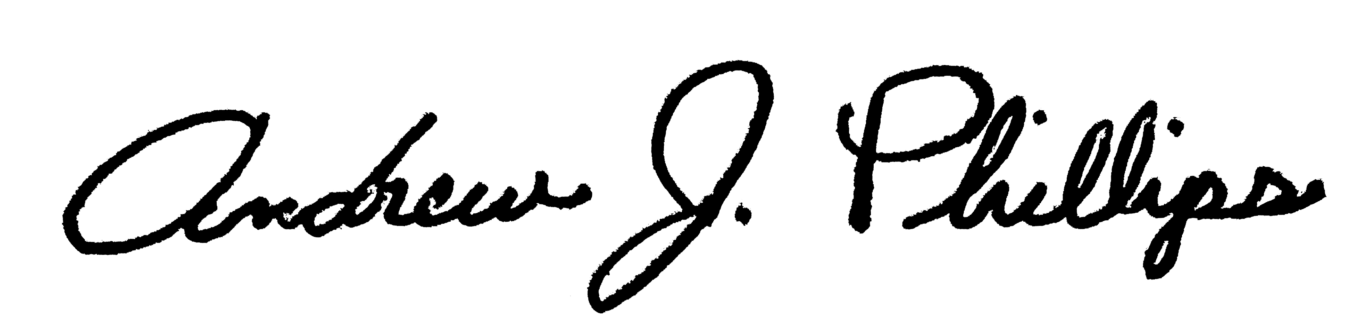
Pastor Andrew

You Are Not Alone!

Your church family is here for you during this unprecedented time in our nation and world. At Calvary, we have always been known for our ability to pull together when something needs to get done. With the direction and oversight of pastor Andrew Phillips, your church leaders have been working on keeping you connected and rooted in Christ.

Leaders have made the commitment to stay in regular contact with every member and friend of our church to keep them informed about resources for Bible study, videoconferencing, devotions, and prayer groups. If you have not been contacted please let us know by connecting with Brian in the office (209.466.0221 or email info@cpcstockton.org), pastor Andrew (pastor@cpcstockton.org) or any Elder or Deacon.

Remember that the church is not a building, rather it is the people who make up the church. That’s you. So even as we continue to have live streamed services, we are still the church and you are still part of it.

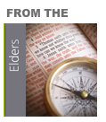

June 21 Calvary resumed In-person Worship Service, following CDC
guidelines. We will continue the services online as well.
July 5 Summer of Psalms teaching series kick off with ice cream
truck following service.
July 6 Start 40 days of Psalm daily Reading plan.
July 19 In-person worship services suspended due to the Governor’s
& CDC Guidelines, in keeping with social responsibility for the safety of our community, Calvary suspended in-person
services until further notice. Service was held online via
website & Facebook; with a Zoom fellowship time following service. We also had a membership class held online.

Wednesdays - Neighborhood walk: to distribute masks as a gift to those living in the area around our church and to let them know about Calvary. Approximately 200 masks have been distributed. Calvary members have been involved in sewing the masks. Anyone who would like to join in the neighborhood walk ministry is welcomed & encouraged to do so. Please contact the church office.

San Joaquin COVID19 Team: Calvary members & others have been sewing masks, making shields & distributing them (approximately 5,000) to area hospitals, care facilities, shelters, & senior services.
Calvary Deacons & the General Fund have made donations to this effort along with other major donors.

June Financials 2020
Income: $15,784.33
Expenses: $38,885.71
Net: - $23,101.38

“But they delight in the law of the Lord, meditating on it day and night. They are like trees planted along the riverbank, bearing fruit each season." - Psalm 1:1-2

Deacon’s Corner
Deacon’s on-going outreach project: Toiletry collection and canned food drive.

CONDOLENCES
Our deepest sympathies at the passing of Inez Hashimoto. The Kenneth Connely Family at the passing of his sister-in-law. The Masada Family at the passing of our beloved Reverend Saburo Masada.

BLESSINGS
Judy Takemoto retired from Segale Travel Agency with 43 years. Congratulations on a well-deserved retirement Judy. Adrian and Melanie Castro gave birth to daughter, Mackenzie Mirai on 5/25/20, 7lbs. 12 oz. Congratulations to you both. Stephanie and Porter Hodkins will be married on August 29,2020 in the presence of their immediate family. Congratulations from all of us here at Calvary. Kyle Natsuhara, who graduated earlier this year.

CONTINUED PRAYERS FOR:
The Masada Family. Aliya Alvarez recovering from a virus infection. Robby in Florida recovering from Covid-19. Prayers for the Calvary Small Group Bible Studies.

Many have asked how you can to continue to support Calvary with offerings and tithes while we are not meeting in person. Please mail your offerings to the church at 2343 Country Club Blvd., Stockton, CA 95204. Thank you for your continued support and God bless you!

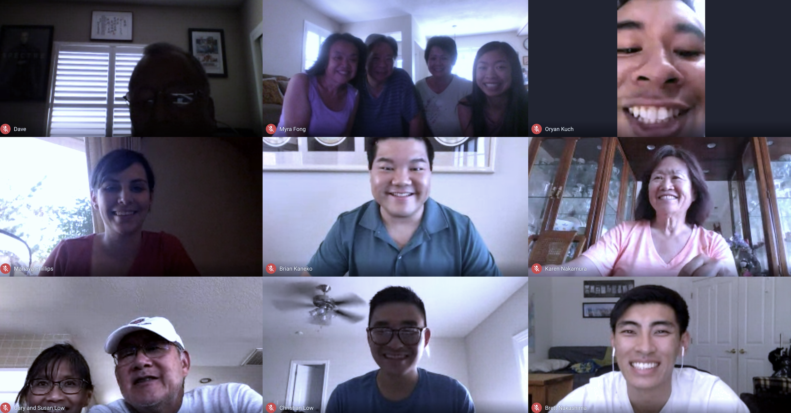
Membership class
We had a great bunch join us for our membership class. We got to know each other better and to learn what membership at Calvary means. We also had the chance to figure out what our spiritual gifts are to help us to grow at church. It was an awesome class and there will be another one coming up in the Fall if you’d like to join us.

Celebrating the Life of Reverend Saburo Masada
On July 20, Rev. Sab went peacefully home to be with his heavenly father. And while we are saddened by this loss, we also know that pastor Sab is in eternal glory with no more pain or sickness. As we reflect and remember pastor Sab's life, we want to celebrate all the ways he invested at Calvary during his time as our pastor. It isn't often that a church can point to a pastor as a pioneer and legacy leader for the congregation. However, Rev. Masada certainly made a bigger impact on our church than we can even begin to describe. We are forever grateful of how he modelled Jesus to us and hope to live up to the legacy he left behind. Please join us in praying for the Masada family, for peace and comfort during this difficult time.

Special Offerings

Deacon’s Fund | Masks for our Community
Ted & Sue Yoneda | Marvin & Kathy Aso
 | Crestwood Manor
Birthday Fund | Nancy DeGuire
Charise Masada | Rose Estrella
 | Peter & Alice Fong
In Memory of Mr & Mrs. Richard Yoshikawa | Golden Oaks Village
Koko Green | Judy Lovett
 | Ken McKinney
In Memory of Aaron Green | Debbie Ornellas
Koko Green | Kathleen Solari
 | Monique Wessel

August 2020
Sunday | Monday | Tuesday | Wednesday | Thursday | Friday | Saturday
26  Live-stream worship  service:  10:00am | 27 | 28 | 29  Pastor’s Devotion | 30  This Sunday @ Calvary! | 31  Office closed | 1
2  Live-stream worship  service:  10:00am | 3  Small Group  Kick-off week! | 4 | 5  Pastor’s Devotion | 6  This Sunday @ Calvary! | 7  Office closed | 8
9  Live-stream worship  service:  10:00am | 10 | 11 | 12  Pastor’s Devotion | 13  This Sunday @ Calvary! | 14  Office closed | 15
16  Live-stream worship  service:  10:00am | 17 | 18  CP Deadline | 19  Pastor’s Devotion | 20  This Sunday @ Calvary!  Theology of the Psalms:  7:00pm to 9:00pm | 21  Office closed | 22
23  Live-stream worship  service:  10:00am | 24 | 25 | 26  CP Mailing  Pastor’s Devotion | 27  This Sunday @ Calvary! | 28  Office closed | 29
30  Live-stream worship  service:  10:00am  Kick-off of new  series:  DNA – Discovering  Our Identity,  Fulfilling our Calling | 31 | 1 | 2  Pastor’s Devotion | 3  This Sunday @ Calvary! | 4  Office closed | 5
Church office hours: Monday – Thursday: 8:30 am – 5:30 pm

