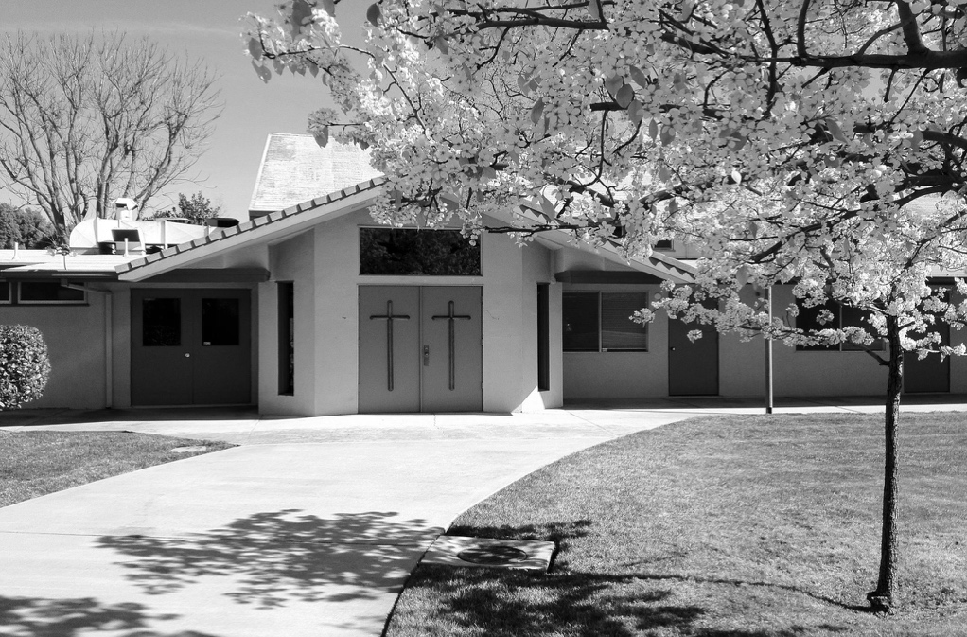

**FEBRUARY 2021**

**VOLUME 2 ISSUE 2**

**What's INSIDE**

2 Board Report

3 Special Offerings

4 Pastor’s Letter

5 Calendar

5 Deacon's Corner

**UPCOMING EVENTS**

**School Supply Drive Delivery:**

Saturday, February 6 from 11:00am to 1pm

**Membership Class:**

Sunday, February 7 from 1:00pm to 3:30pm

**School of Theology:**

Saturday, February 20 from 9:30am to 4:00pm

Publication of Calvary Church, 2343 Country Club Blvd, Stockton, California 95204

**THE CALVARY PRESS**

We may complain about the worship styles of certain churches, judge the quality of the coffee served or the appearance of the building. I don’t mention these things to belittle or downplay the experiences of Christians in the U.S. The truth is that the things we worry about in the church in the West *DO MATTER* to our ability to reach people far from God in our community. However, we’d do well to remember and pray for those persecuted believers around the world.

(Continued on page 4)

About a decade ago the Twitter hashtag, “#firstworldproblems”, went viral online through social media sites like Twitter and Facebook. The hashtag was a condescending way to talk about problems that everyday people face in the Western world – slow internet connections, poor phone coverage, and getting a bad haircut. Problems that, while they may be inconvenient, pale in comparison to the real challenges that people face around the world.

A few weeks ago, we learned one specific way to receive God’s provision this year – through trials. Since that message, I’ve been thinking about the #firstworld*church*problems that Christians in the West face, and their comparison to the real suffering that our brothers and sisters around the world experience.

Calvary Press

Page 2

**CALVARY BOARD REPORT**

**2020 Financial Statement**

Income: $273,230.24

Expenses: $215,451.36

Net: +$  57,778.88

“If my people who are called by my name humble themselves and pray and seek my face and turn from their wicked ways, then I will hear from heaven and will forgive their sin and heal their land.” – 2 Chronicles 7:14 (ESV)

Pray for our nation and our leaders. Christians need to unify, turn back to God, be good examples & do their best to represent Him. Seek the good of our country.

-23,000 masks distributed to our community through the mask ministry

-Over 25 young adults involved in Catalyst’s weekly ministries

-50-60 young men attending Calvary’s open gym night.

**2021 budget presented and ratified**

**Commissioning & appointing Eldership:**

Andrew Phillips & Brett Nakashima

**Commissioning & electing Deacons:**

Janice Chan, Trisha Fong, Dave Furukawa, Brian Kaneko, Ilene Kuwahara, Willie Low, Hisako Smith, Gene Wong

**Electing as Board Members to 1-year term:**

Myra Fong, Cori Kambara, Gary Low, Mary Nakamura, Brett Nakashima, Andrew Phillips, Steve Takemoto, Sally Tsunekawa

2021 Master Calendar presented:

**January – March Highlights**

Jan.–Feb.: School Supply drive

Feb. 7: Membership Class

Feb. 20: School of Theology:  Residential Day

April: Easter

**Annual Gratitude Meeting January 17, 2021 Worship & Business Meeting**

The Annual report was emailed and printed for all. Printed copies available to be picked up at the church.

**Annual Report Highlights:**

-Four made a decision to follow Jesus for the first time

-New partnership with Converge network, allowing & enabling us to plant churches

-14,000 people reached by our church in the Greater Stockton area through social media

PRAYER REQUESTS:

* Healing prayers answered for Nico’s fractured arm.
* Edgar Tracy has recovered from COVID.
* Healing prayers for Richard and Polly Johnston recovering from COVID.
* Healing prayers for Dave’s family.
* Healing prayers for the Espinoza family.
* Healing prayers for the Foosum family.
* Healing prayers for the Wehrli family.
* Healing prayers for Felipe Llamas.
* Prayers for Yvonne Tibon at the loss of her faither
* Prayers for Tim’s cancer treatment.
* Prayers for those affected from COVID.
* Prayers for leaders of our great nation.
* Prayers for the men and women of our armed forces.

## DEACON’S CORNER

**BIBLE TRIVIA**

- In what city was Jesus born?

_______________________________

- How many books are in the New Testament?

_______________________________

- How many people did Jesus feed with fives loaves of bread and two fish?

_______________________________

- After Jesus was arrested, which apostle disowned him three times?

_______________________________

The answers will be revealed in next month’s Calvary Press!

-

|  |  |  |  |  |  |  |
| --- | --- | --- | --- | --- | --- | --- |
| SUN | M | T | W | TH | F | SAT |
| 31  **Worship**  **Service:**  10:00am | 1  **Prayer Night**  7:30pm – 8:30pm | 2  **Small Group:**  7:30pm | 3  Pastor’s Devotion  **Small Group:**  10:00am  **Catalyst Life Group:**  7:00pm – 9:00pm | 4  Weekly Email Newsletter | 5  Office closed | 6  **School Supply Drive:**  11:00am – 1:00pm |
| 7  **Communion**  **Invite A Friend**  **Worship Service:**  10:00am  **Membership**  **Class**:  1:00pm –  3:30pm | 8  **Prayer Night**  7:30pm – 8:30pm | 9  **Small Group:**  7:30pm | 10  Pastor’s Devotion  **Small Group:**  10:00am  **Catalyst Life Group:**  7:00pm – 9:00pm | 11  Weekly Email Newsletter | 12  Office closed | 13 |
| 14  **Worship**  **Service:**  10:00am | 15  CP Deadline  **Prayer Night**  7:30pm – 8:30pm | 16  **Small Group:**  7:30pm | 17  **Pastor’s Devotion**  **Small Group:**  10:00am  **Catalyst Life Group:**  7:00pm – 9:00pm | 18  Weekly Email Newsletter | 19  Office closed | 20  **Calvary School of Theology: Residential Day:**  9:30am – 4:00pm |
| 21  **Worship**  **Service:**  10:00am | 22  **Prayer Night**  7:30pm – 8:30pm | 23  **Small Group:**  7:30pm | 24  Pastor’s Devotion  CP Mailing  **Small Group:**  10:00am  **Catalyst Life Group:**  7:00pm – 9:00pm | 25  Weekly Email Newsletter | 26  Office closed | 27  **Men’s Fellowship**  **Breakfast:**  8:00am |
| 28  **Worship**  **Service:**  10:00am | 1  **Prayer Night**  7:30pm – 8:30pm | 2  **Small Group:**  7:30pm | 3  Pastor’s Devotion    **Small Group:**  10:00am  **Catalyst Life Group:**  7:00pm – 9:00pm | 4  Weekly Email Newsletter | 5  Office closed | 6 |

Calvary Press

Page 5

Non-Profit Organization

U.S. Postage Paid

Stockton, California

Permit No. 161

Calvary Church

2342 Country Club Blvd

Stockton, California 95204

* Diagram

  Description automatically generated

We are a welcoming, casual and diverse church in the heart of Stockton’s beautiful Country Club neighborhood. We are a community where you are welcomed whether you are new to faith or a lifelong follower of Jesus.

For more information **call**: 209-466-0221 or **email**: info@calvarystockton.church

Visit our **website**: www.calvarystockton.church or **Facebook**: www.facebook.com/calvarystockton

**Office Hours**: Monday through Thursday from 8:30am to 5:30pm

**Wednesday Prayer Walk**

Every Wednesday

2pm to 3pm

**Small Groups**

Tuesday Night: 7:30pm

Wednesday morning: 10am

Wednesday night: 7pm

Get involved in weekly ministries:

**Worship service**

Every Sunday

10am to 11am

**Prayer Night**

Every Monday

7:30pm to 8:30pm

**Calvary Church “Centering People in Christ”**

RETURN SERVICE REQUESTED

Glory in His holy name; let the hearts of those who seek the LORD rejoice!

Address label

Page 3

|  |
| --- |
| **Thanksgiving** |
| Frank Yoneshige |
|  |
| **Christmas** |
| Aiko Aoyama |
| Cynthia Chan-Wong |
| Dean & Liane Komure |
| Mary Lam |
| Willie & Anna Low |
| R. Mitsuo Nakamura |
| Kazumi Nishioka |
| John & Ruth Oda |
| Randy & Dee Olson |
| Duane & Jeannie Sakoda |
| Kurt Shigematsu |
| Peter & Tatsumi Stearns |
| Hisaye Takahashi |
| Steve & Barbara Takemoto |
| Gene & Marcy Wong |
| Kevin & Susan Wong |
| Frank Yoneshige |
|  |
| **Christmas Photos** |
| Loretta Davidson |
|  |
| **Operation Christmas Child** |
| Ruth Yoneshige |
|  |
| **School Supply Drive** |
| Janice Ishimaru |

|  |
| --- |
| **Staff Appreciation** |
| Richard & Janet Menor |
| Gene & Marcy Wong |
|  |
| **In Memory of Ed & Aiko Yoshikawa** |
| Craig Yoshikawa |
|  |
| **In Memory of Dr. Kenji & Mrs. Helen Oshidari** |
| Ken & Jacqueline Oshidari |
|  |
| **In Memory of Katie Komure** |
| Dun Family |
| Jeannie Matsumoto |
| Semih & Jeanne Sabankaya |
| Kent & Patti Yep |
|  |
| **In Memory of Tadashi Agari** |
| Judy Takemoto |
| **In Memory of Marie Nakade** |
| Shirley Bertoni |
|  |
| **In Memory of Higashiyama Family** |
| Shirley Bertoni |
|  |
| **In Memory of Roy Yonemoto** |
| Ray & Judy Yamagishi |
|  |
| **Birthday Fund** |
| Jim & Sally Tsunekawa (Jim & Rina Tsunekawa) |

**SPECIAL OFFERINGS**

Dear members and friends of Calvary Church,

I’d like to express my heartfelt thank you for the thoughtful Christmas gift to me. I’m very grateful for the opportunity to work at this caring church.

With Appreciation,

Tatsumi Stearns

Calvary Press

You may remember a particular example I shared in my *Provision through Trials* message. It was the story about a woman from Iran, who became a believer and was forced to practice her faith underground for fear of being caught and killed for her belief in Jesus. There are countless others who face immense persecution for simply pledging allegiance to Jesus. They face the same kind of problems that the early church believers came up against in Acts.

I remember a few years ago, meeting with a woman in the UK who had escaped religious persecution in Eritrea. Her husband was unable to make it out with her and, since he was likely imprisoned for his faith, she had not seen him in over 7 years. Yet her story inspired me. Even in the midst of that trial, she praised God and was thankful. By my standards she did not have much, but she was thankful for God’s provision and praised Him all the more for what God had done in her life.

In two short weeks we celebrate Valentine’s Day. Couples exchange chocolates and cards, while every schoolkid in America gets a chance to find a “special” valentine in their classroom. But moreover, Valentine’s Day was originally celebrated to remember St. Valentine. He was a minister in Roman in the third century – during the Roman emperor’s genocide of Christians.

**For more encouraging devotionals**

Go to our website ***www.calvarystockton.church/blog*** for a new devotionals every Wednesday. It’s a great way to get uplifted and to be filled with the Holy Spirit during the week!

Often today associated with romance and devotion, St. Valentine is more aptly remembered as a symbol of Christian martyrdom. According to historical tradition, he was caught helping persecuted Christians and sentenced to death. He was martyred in Rome on February 14, 256 AD. Even leading up to his death, Valentine tried everything he could to share the Gospel with the Roman emperor and see him accept Jesus as his savior.

And maybe this month, as you celebrate Valentine’s day, you can reflect on the sacrifice of Christians around the world. Pray for them as Paul instructs the believers in the New Testament.

Open Doors, which serves persecuted Christians around the world by organizing secret missions and Bible supplies in places where the Gospel is not legal, has a prayer pledge on their website:

www.opendoorsusa.org

I’d encourage you to sign up for it and commit in this Year of Provision to praying for provision for our persecuted brothers and sisters in Christ.

Yours in Christ,

Pastor Andrew

## (continued from page 1)

Page 4

Calvary Press