Calvary Presbyterian Church Non-Profit Organization
2343 Country Club Blvd. U.S. Postage Paid
Stockton, CA 95204 Stockton, California
Permit No. 161

RETURN SERVICE REQUESTED

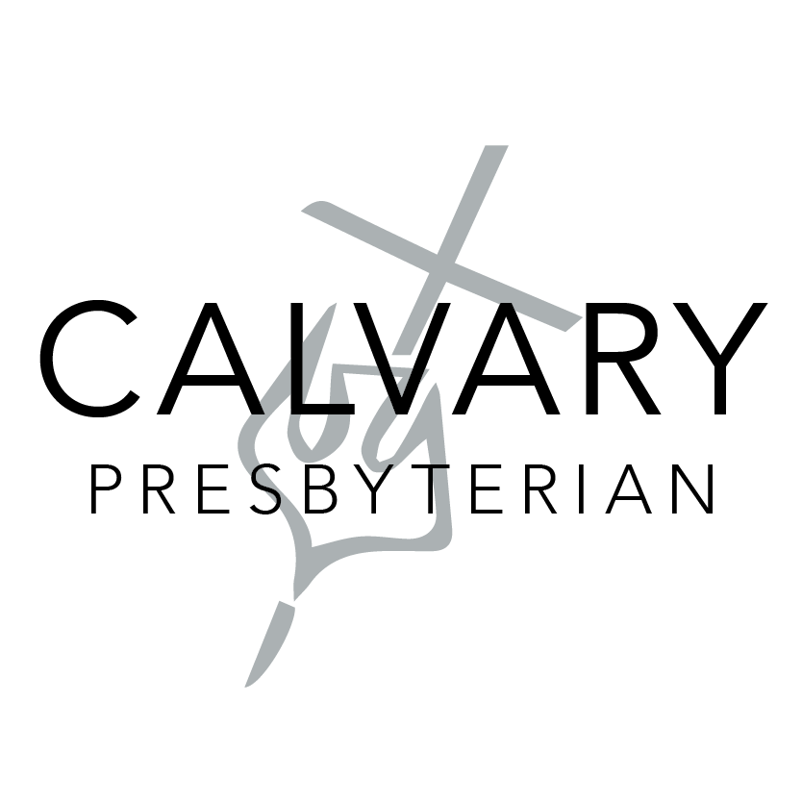

Upcoming Events

Oct. 3 from 12:00pm to 2:00pm
School supplies delivery

Oct. 4 from 6:00pm to 7:00pm
Prayer night kickoff

Oct. 11 from 11:30am to 12:30pm
Congregational meeting

Oct. 17 from 8:30am to 11:30am
Calvary cleanout day

Oct. 18 from 2:30pm to 4:00pm
Membership class

OCTOBER 2020
CALVARY PRESS
Phone: (209)466-0021
Email: info@cpcstockton.org
Website: www.cpcstockton.org
Facebook: www.facebook.com/calvarystockton
We're a welcoming, casual and diverse church in the heart of Stockton's beautiful Country Club neighborhood. Calvary is a community where you'll be welcomed, whether you're new to faith or a life-long follower of Jesus.

Letter from the pastor
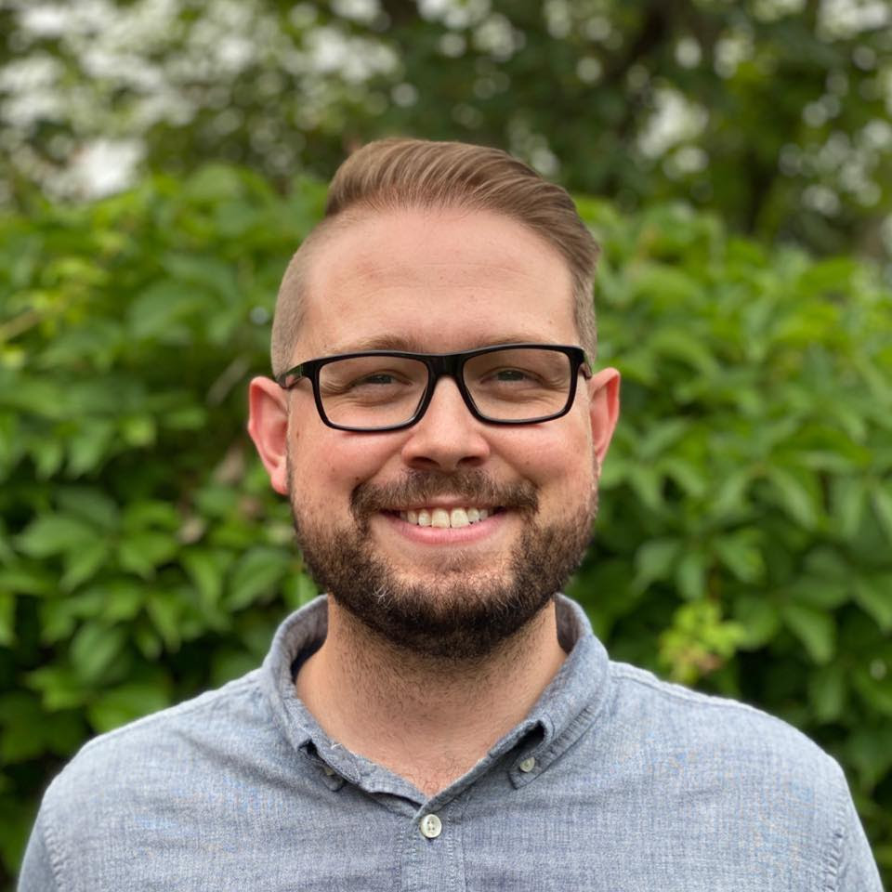

Matthew 22:15-20

Then the Pharisees met together to plot how to trap Jesus into saying something for which he could be arrested. They sent some of their disciples, along with the supporters of Herod, to meet with him. “Teacher,” they said, “we know how honest you are. You teach the way of God truthfully. You are impartial and don’t play favorites. Now tell us what you think about this: Is it right to pay taxes to Caesar or not?” But Jesus knew their evil motives. “You hypocrites!” he said. “Why are you trying to trap me? Here, show me the coin used for the tax.”

Continued

As election day draws near, I’m acutely aware of the political statements filling our social media accounts, tv ads, and even our mailboxes.
I’ve always been careful when talking about my political stances. Speaking as a Christian and a pastor, I am acutely aware that leading a congregation precludes me from being absolutely free with my speech.
Congregations are, like the country, likely divided, and they would rather not admit that they have a political litmus test for the pastor (the pastor would like to not be fired if it is found out he was really a closet Republican, Democrat, libertarian, socialist, etc.!)
And so like-minded pastors across the country, as election day nears, come up with a language that is somehow mediating between political extremes. We speak in ways that attempt to bridge gaps, and we speak of the need to unite and move on.
We seek to stand above the petty disputes of mere political parties, because if we are just mouthpieces for parties, we are taking our trust in God and giving it to contingent and fallible human institutions. And yet, we mediate.
We seek in those moments to steer clear of being pinned down on this question: who did you vote for? Or: do you think I'm not Christian because I voted for this candidate?
This kind of mediating language is useful and can be healing for a congregation that is tired of punditry and endless politicization. In times of conflict, the language of reconciliation is mandatory and not simply an attempt to be safe.
And the reason for that is, at the core, our world’s problems will never find a solution in the platform of a political party. We may agree or disagree on individual parts of a political party’s platform for Biblical reasons, but to trust in politics is, ultimately, putting one’s trust in a fallible and human institution.

When they handed him a Roman coin, he asked, “Whose picture and title are stamped on it?” “Caesar’s,” they replied. “Well, then,” he said, “give to Caesar what belongs to Caesar, and give to God what belongs to God.”

I thank God that we have a different and more secure citizenship as brothers and sisters in the Kingdom of God.
Jesus illustrates this through one of my favorite stories in the Gospel, from Matthew 22:15-20.
Then the Pharisees met together to plot how to trap Jesus into saying something for which he could be arrested. They sent some of their disciples, along with the supporters of Herod, to meet with him. “Teacher,” they said, “we know how honest you are. You teach the way of God truthfully. You are impartial and don’t play favorites. Now tell us what you think about this: Is it right to pay taxes to Caesar or not?” But Jesus knew their evil motives. “You hypocrites!” he said. “Why are you trying to trap me? Here, show me the coin used for the tax.” When they handed him a Roman coin, he asked, “Whose picture and title are stamped on it?” “Caesar’s,” they replied. “Well, then,” he said, “give to Caesar what belongs to Caesar, and give to God what belongs to God.”
A poll tax was a tax that was specifically imposed on the Jewish people. If you were a Jew, you had to pay this tax, while if you were a Roman, you were exempt. The equivalent today would be if the government decided to levy a tax on all men in the US, while all women were exempt. Clearly, it was an unfair tax.
The Pharisees had every right to object the tax. But in the question, they were trying to trap Jesus. If Jesus supported the tax, he would be labelled by the Jewish people as a Roman sympathizer. If he rejected the tax, the Pharisees would surely use this to have him marked as an enemy of the state—a revolutionary!
But Jesus knows their intentions and instead uses the question to uncover their hypocrisy. He asks them to provide the coin used for the tax, since coins used in that day had inscriptions of the
Roman government. And on the front of that particular coin would have been a bust of Caesar, along with the inscription ‘Divis Filius,’ which means ‘son of a god.’
This coin was a physical representation of idolatry. Possessing it would have been offensive to the point of sacrilege to the Jews. It claimed that Caesar was the son of a god!
The point is, in choosing to return the coin to the authorities, Jesus is giving us an important example to follow. That if we put our trust in government, it will always fall short of the ONE thing that we should put our faith in. It’s a form of idolatry that distracts you from God.
Don’t misunderstand me, because I’m not saying that standing as a Christian for what you believe in is unimportant. Rather, I’m asking that you remember what really matters this year as the election draws near.
Your political stances don’t define you. Your voting choice isn’t more important than your citizenship to God’s Kingdom, and your call as a Christian to protect the unity of the church.
As God’s people we would do well to remember that we can stand together for the Gospel—together as Republicans, Democrats and Independents—and continually point back not to the current political climate, but to our shared faith in true salvation through Christ’s death and resurrection.
Yours in Christ,
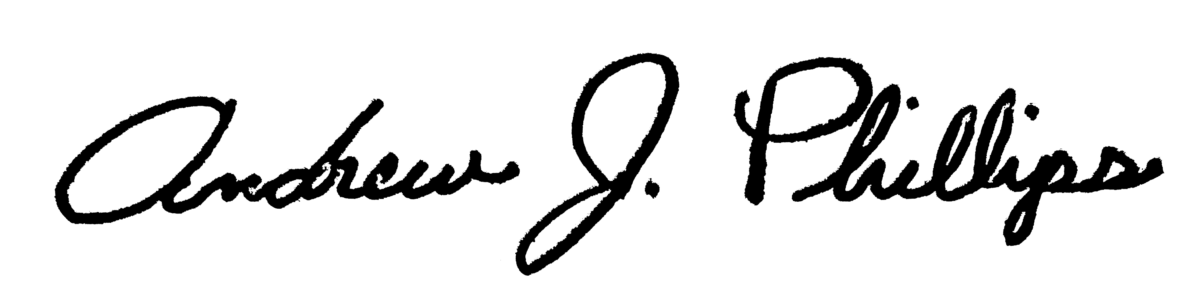
Pastor Andrew

From the Elders

Congregational Meeting:

We look forward to welcoming you to the meeting and celebrating our renewed vision and mission as a church to reach our city with the Gospel. If you need a printed copy of the bylaws or have any questions, please don’t hesitate to reach out to the church office at info@cpcstockton.org or by phone: (209)466-0221. We will be having the meeting after our service on Sunday, October 11 at 11:30am. To access to the meeting, go to: cpcstockton.org/
congregationalmeeting.

We don’t need a special place to meet with God: We have access to God through Jesus who brought the temple into our hearts through the Holy Spirit: however and wherever we are.

Pastor’s Report:
1. Statistical Report: Online Worship attendance averaging 180. Our interest is not just the numbers, but in discipleship.
2. September Membership renewal: All members must renew their membership to Calvary by attending the membership class or reaffirming their membership covenant.

Congregational Meetings:
September 6: A motion was passed for Calvary to transition out of ECO and to become an independent church.
October 11: To approve the new Calvary Bylaws. Members will receive an email or a letter regarding the meeting & can request a copy of the bylaws.

August Financials:
Income: $15,026.89
Expenses: $10,900.74
Net $ 4,126.10

Deacon’s Corner
Deacon’s on-going outreach project: Toiletry collection and canned food drive.
BLESSINGS:
Thanks everyone for healing prayers for Dan's knee. He's able to return to work.
HEALING PRAYERS:
For California and our firefighters at the frontlines of the fires.
Prayers for Tony. He will be in Hospice Care once the family visits.
Prayers for John and Ruth Oda. Both have been experiencing health issues.
Prayers for Luis' cousin Sam. His liver is failing, and his cancer is not looking good.
Continued prayers for Julie's father-in-law, John.
Prayers for Sally's daughter-in-law's sister, Eunice. Suffering respiratory symptoms of COVID-19.
Prayers for God's blessings and guidance for Calvary and all Christian churches to be a light to the world and prayers for reopening of all churches.

How can we pray for you?
Text your prayer request to:
(209)712-4207

Because of this, I say to you, whatever you ask for when you pray, have faith that you will receive it. Then you will get it.
- Mark 11:24

Thank you, Jesus!

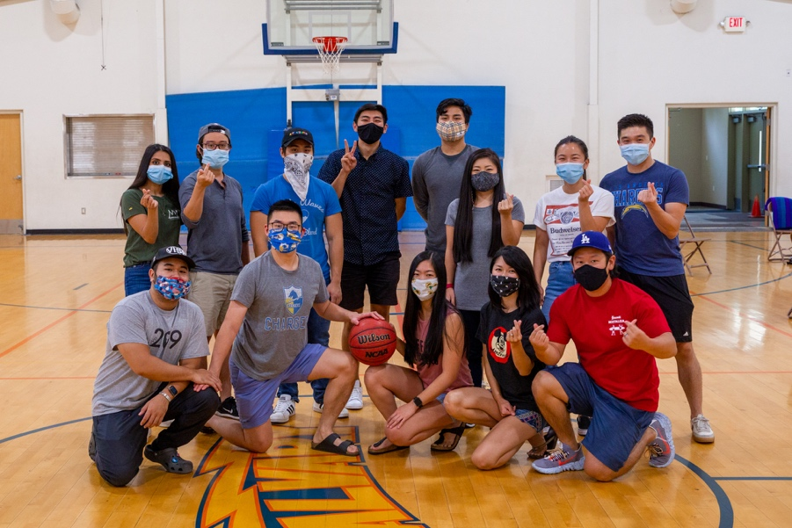

Catalyst Young Adult Ministry
On September 13th, through much prayer and consideration, Calvary officially established Catalyst Young Adult Ministry. The mission of this ministry is to equip young adults to find their way back to Jesus and stay centered in Him. We are excited for this new opportunity God has presented us with and we ask for your prayers as we seek the LORD’s guidance through this area of ministry.

Calvary Prayer Night Kickoff
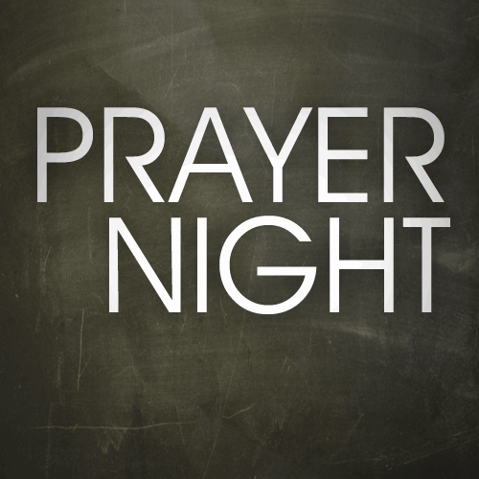
Even though there’s nothing
we can do to earn God’s love
or save ourselves from sin
and death, we still have a
choice. We can give in to our
pride, staying distant from
God. This means that our sin
will separate us from God f
forever in hell. Or, we can
choose to accept what Jesus
did for us and begin living
free from consequences of
sin. This means we will
spend eternity with Him in
heaven. We can rely on our
own performance plan, or we
can trust Jesus to do what we
can’t do for ourselves. The
choice is up to us.

- Charise Masada

We will be holding a weekly prayer evening to renew, encourage, and equip you in your faith! It’ll be a time of worship and prayer. Spending time with God, celebrating, drawing close, and praying bold prayers. We will be kicking off THIS Sunday, October 4 at 6pm. We hope to see you there!

Calvary Fall Cleanout Day
It is that time of the year to do a little fall clean up. I’m sure a lot of us have things that we went to get rid of. On Saturday, October 17 from 8:30am – 11:30am, you will get the chance. Just come by the church and drop off the items you want to get rid of. There are items that we can’t take, such as: mattresses, e-waste, chemicals/drugs, or hazardous materials. We are also requesting a monetary donation. Thank for the support and we hope to see you there.
- Brian Kaneko

Operation Christmas Child

The COVID-19 global pandemic has disrupted everyday life for millions of people around the world. Yet, Samaritan’s Purse continues to share the eternal hope of the Gospel and to serve in Jesus’ Name. We want boys and girls around the world to know that God loves them and has not forgotten them during this time of fear and uncertainty. Children need great joy now more than ever. Most of all, they need the hope found only in the Gospel of Jesus Christ.

At this time there are no changes as to what can and can’t be packed in shoebox gifts this year.
Calvary would like to fill boxes for boys and girls ages 2-14
Membership class

Not a member yet? Want to find out what membership at Calvary is all about? You’re invited to our next membership class! It will be on October 18 from 2 to 4:30pm.

Go to www.cpcstockton.org/

membership to get signed up!

School supplies: pencils, pens, notebooks, children’s scissors; coloring books; toys; combs, brushes —-that would fit into a 13 x 7 x 5 box.

If you would like to shop for items, they can be dropped off at the Calvary office, labelled “Operation Christmas Child” and/or items can be bought from monies donated to Operation Christmas Child. It will be $9 per box to collect, process and ship shoebox gifts and to provide for ministry materials.

NOTE: We have enough crayons (for OCC & the neighborhood project) and enough wash cloths & soap.

November 8-14: Fill Shoe boxes & write notes: details to follow
November 15th: Shoe box dedication
November 16–23: National collection week-our boxes taken to a local drop-off location

Special Offerings
In Memory of Rev. Saburo Masada
Tom & Tsuru Miyasaki
Sam & Sumi Motoike
Jerry & Karen Nakamura
Jim & Sally Tsunekawa
Hanae Watanabe

Deacon’s Fund in Member of Rev. Masada
Roy & Emily Takuechi

47th Wedding Anniversary Masks for our Community
Jim & Sally Tsunekawa United Way of San Joaquin
County
Birthday Fund
Aiko Aoyama, Jerry & Karen Nakamura (Jerry & Katelyn), Jim & Sally Tsunekawa (Milia Tsunekawa)
October 2020
Church office hours: Monday – Thursday: 8:30am – 5:30pm
Sunday | Monday | Tuesday | Wednesday | Thursday | Friday | Saturday
27  Live-stream  worship service:  10:00am | 28 | 29 | 30  Pastor’s Devotion | 1  This Sunday @ Calvary! | 2  Office closed | 3  School supplies delivery:  12pm – 2pm
4  Live-stream  worship service:  10:00am  Prayer Night  Kickoff  6:00pm – 7:00pm | 5 | 6 | 7  Pastor’s Devotion | 8  This Sunday @ Calvary! | 9  Office closed | 10
11  Live-stream  worship service:  10:00am  Online  Congregational  Meeting:  11:30am –  12:30pm  Prayer Night  6:00pm – 7:00pm | 12 | 13 | 14  Pastor’s Devotion | 15  This Sunday @ Calvary! | 16  Office closed | 17  Calvary Fall  Cleanout Day  8:30am –  11:30pm
18  Worship Service:  10:00am  Membership  class:  2:30pm – 4:00pm  Prayer Night  6:00pm – 7:00pm | 19 | 20  CP Deadline | 21  Pastor’s Devotion | 22  This Sunday @ Calvary! | 23  Office closed | 24
25  Worship Service:  10:00am  Prayer Night  6:00pm – 7:00pm | 26 | 27 | 28  CP Mailing  Pastor’s Devotion | 29  This Sunday @ Calvary! | 30  Office closed | 31

