Calvary Church Non-Profit Organization
2343 Country Club Blvd. U.S. Postage Paid
Stockton, CA 95204 Stockton, California
Permit No. 161

RETURN SERVICE REQUESTED

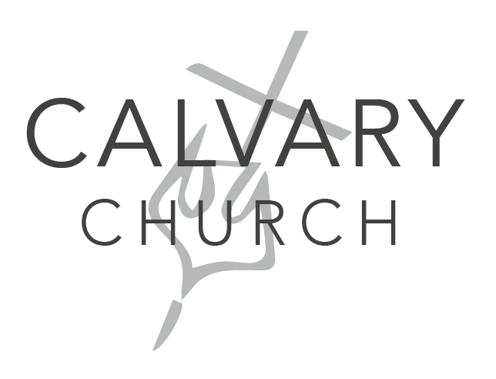

Upcoming Events

Every Wednesday from

2:00 – 3:00pm
Neighborhood Outreach

Nov. 8 at 10:00am

Church in the Park
Nov. 15 at 10:00am
Invite a Friend Sunday
Nov. 22 at 10:00am
Vision Sunday

NOVEMBER 2020
CALVARY PRESS
Phone: (209)466-0021
Email: info@calvarystockton.church
Website: www.calvarystockton.church
Facebook: www.facebook.com/calvarystockton
We're a welcoming, casual and diverse church in the heart of Stockton's beautiful Country Club neighborhood. Calvary is a community where you'll be welcomed, whether you're new to faith or a life-long follower of Jesus.

Put on God’s Armor
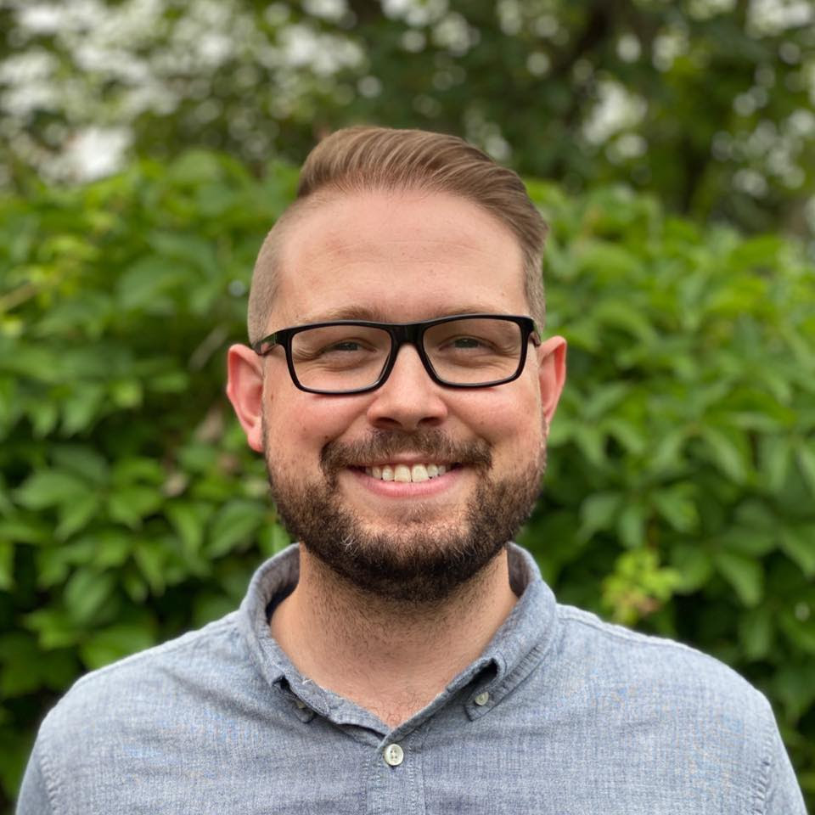
Ephesians 6:10-17
¹⁰ Be strong in the Lord and in his mighty power. ¹¹ Put on all of God’s armor so that you will be able to stand firm against all strategies of the devil. ¹² For we are not fighting against flesh-and-blood enemies, but against evil rulers and authorities of the unseen world, against mighty powers in this dark world, and against evil spirits in the heavenly places.¹³ Therefore, put on every piece of God’s armor so you will be able to resist the enemy in the time of evil. Then after the battle you will still be standing firm. ¹⁴ Stand your ground, putting on the belt of truth and the body armor of God’s righteousness.

Continued

No matter how much life may be weighing us down, we can rise above the challenge because we have God’s strength. That’s what Ephesians 6 reminds us when it calls us to put on the full armor of God in preparation for the spiritual battle in front of us.
You can be certain that you’re facing a spiritual battle. The enemy (Satan) doesn’t want you to grow in your faith. He wants to distract and discourage you – to fill you with fear, anxiety, and worry.
But the spiritual battle before you is far greater than just negative thoughts and emotions, because every second you spend worrying spills over into your relationships, your career and especially into your spiritual growth.
The longer the enemy can keep you focused on your situation, instead of your savior, the more he can distract you from growing in your faith.
- The belt of truth: Discerning the difference between lies and truth. Knowing the truth comes from being rooted in God’s word.
- The body armor of righteousness: If you know the truth, you have to live it out. Living and doing the right things protects you from temptation.
- The shoes of peace: The Gospel are the shoes of peace. When you share the hope of Jesus with someone, it brings peace. Peace that Jesus has overcome their sin.
- Shield of faith: Trusting God even when you don’t see His hand. Spiritual temptations are worse when we don’t feel God’s presence, but if you have faith you can trust that God is still with you even when you don’t see it.
- Helmet of salvation: The assurance that God has already won!
- The sword of the Spirit: Having the wisdom of the Holy Spirit to guide and protect you.
But Ephesians reminds us that, though we face a spiritual battle, we don’t do it alone. God gives us His spiritual armor. Maybe you’ve read Ephesians 6 before and struggled to connect the armor to your real-life situations. But know this – God’s armor, when you put it on, will give you wisdom, strength and courage for the spiritual battle:

¹⁵ For shoes, put on the peace that comes from the Good News so that you will be fully prepared. ¹⁶ In addition to all of these, hold up the shield of faith to stop the fiery arrows of the devil. ¹⁷ Put on salvation as your helmet, and take the sword of the Spirit, which is the word of God.

The Having God’s strength isn’t only about how God will help us in our careers, relationship and life situations. It’s about how God’s strength will help us fight every spiritual battle against our sins, struggles and bad habits.
This is what Ephesians has been building up to; first, it talked about how we are saved (by grace through faith in Jesus), and then it talked about what we are saved to (to shine a light on the world’s darkness and sin). But now, it’s talking about how our salvation can help us in battle – the battle against the world and the world’s systems, our own sins and against the spiritual forces of the enemy.
Having the armor of Jesus – the belt of truth, armor of righteousness, shoes of peace, shield of faith, helmet of salvation and the sword of the Spirit – is having the spiritual truths that we need to fight this battle.
There are a lot of strongholds in our lives that need to be torn down with God’s power. They can be anything from negative emotion, to addiction to things which consume like anger, jealousy or greed. The good news is that we already hold the full strength of God to defeat these strongholds – we just need to give them up to Jesus. When we decide that we’re not going to be consumed by these strongholds we can start to replace them with the armor of Christ.
What are the strongholds in your life? Are you willing to break through them by acknowledging that God has more power and strength than those strongholds?

In Ephesians 3:20 it says:
Now all glory to God, who is able, through his mighty power at work within us, to accomplish infinitely more than we might ask or think.
God is able to accomplish so much more than we could ever ask or even imagine! So much more! If you think God can never take that stronghold away from you, He can! You just need to give Him the keys and trust that He is able to do more than you can even ask for, as you put on His armor.
There’s a battle going on right now, and the enemy wants to steal and kill every good thing God has in store for you. But because of Jesus we fight from a position of victory. We can beat every evil spiritual force and sin because of Jesus.

Yours in Christ,
Pastor Andrew

From the Elders

Church in the Park
Join us for worship as we fellowship, celebrate, and witness through a special service in the heart of our neighborhood. On Sunday, November 8 at 10am, we’re holding our service at American Legion Park, at the corner of Bedford and Baker. Invite a friend to join you as we worship, hear a powerful message, and enjoy safe fellowship at the end of our service.

All jobs at church are equal and are to honor and glorify God.
Each member uses their gifts to serve the church; each role is important and valued.

1 Chronicles 9:28-31 – Mattithiah the bread maker and
1 Corinthians 12 – Spiritual gifts

October 13 – Membership class
October 25 – Resumed in person worship with COVID safety precautions; with live stream
New LED lighting was installed in the gym

October Financials:
Income: $13,256.37
Expenses: $22,042.46
Net - $ 8,786.09

Deacon’s Corner
BLESSINGS:
- The Phillips family’s newest addition, Amelia Rose.
- The Takemoto’s granddaughter, Emiko Moyer’s, successful eye surgery.
- God’s blessing to newlyweds, Christian and Shivani Low.
HEALING PRAYERS:
- For Sonsik Furukawa’s injured shoulder.
- God’s peace and comfort for the Komure family for the passing of Mrs. Katie Komure.
- Prayers for Benny Chun who has been diagnosed with brain cancer.
- Continued prayers for Luis' cousin Sam. His liver is failing, and his cancer is not looking good.
- Prayers for God's blessings and guidance for Calvary and all Christian churches to be a light to the world and prayers for reopening of all churches.
- Prayers for Converge Church Planting Assessment Center.
The 36th Annual Calvary Golf Tournament

How can we pray for you?
Text your prayer request to:
(209)712-4207

Do not be anxious about anything, but in everything, by prayer and petition, with thanksgiving, present your requests to God.
- Philippians 4:6

This year’s tournament consisted of 11 teams starting a shotgun start at 10 o’clock in the morning. The men’s winning team consisted of Steve Takemoto, Craig Pearce, Larry Hintz, and Beau Hintz with the lowest score of 69 for the men. The women’s winning team consisted of Amelia Garibaldi, Kelly Dun, Cyndy Shiromizu, and Julie Garibaldi with the lowest score of the tournament at 68. The men’s longest drive was won by Beau Hintz which was measured at 323 yards and the women’s longest drive was won by Amelia Garibaldi at 239 yards. The men’s closest to the pin was won by John Nakashima at 9’ 7” and the women’s closest to the pin was won by Amelia Garibaldi at 10’ 8”.
Calvary Church would like to thank the following people for their donations to the tournament: Steve and Barbara Takemoto, John Nakashima, Karen Nakamura, Stan Kaneko, Kelly Dun, Sally Tsunekawa and Cyndi Shiromizu.
The tournament was chaired by Gary Low and Willie Low with the help of Rosemary Chin and Daisy Chew.
Next year’s tournament will be held on September 25, 2021.
Operation Christmas Child

Wednesday Small Group
(Fan or Followers)!

The goal of this study is to challenge us to become better FOLLOWERS of Christ and not just FANS.
The Wednesday morning bible study, led by Ron Kuwahara, was off to a roaring start. We had a total of 6 of us as we re-started our Wednesday morning bible study. Our variety of snacks and treats were obviously missing. So when Roy and Emily are feeling safe to return, please join us and don't forget to make a stop over at Trader Joe's.
And sadly, the class is not as warm nor as bright without the presence of our beloved, Katie Komure. May her life, devotion to God and her eternal faith lie everlasting in our hearts!
- Dave Furukawa

The COVID-19 global pandemic has disrupted everyday life for millions of people around the world. Yet, Samaritan’s Purse continues to share the eternal hope of the Gospel and to serve in Jesus’ Name. We want boys and girls around the world to know that God loves them and has not forgotten them during this time of fear and uncertainty. Children need great joy now more than ever. Most of all, they need the hope found only in the Gospel of Jesus Christ.

At this time there are no changes as to what can and can’t be packed in shoebox gifts this year.
Calvary would like to fill boxes for boys and girls ages 2-14.
School supplies: pencils, pens, notebooks, children’s scissors; coloring books; toys; combs, brushes —-that would fit into a 13 x 7 x 5 box.

If you would like to shop for items, they can be dropped off at the Calvary office, labelled “Operation Christmas Child” and/or items can be bought from monies donated to Operation Christmas Child. It will be $9 per box to collect, process and ship shoebox gifts and to provide for ministry materials.

NOTE: We have enough crayons (for OCC & the neighborhood project) and enough wash cloths & soap.

November 8-14: Fill Shoe boxes & write notes: details to follow
November 15th: Shoe box dedication
November 16–23: National collection week-our boxes taken to a local drop-off location

The Thanksgiving and Christmas season is upon us and we would like to express our appreciation for our hard-working church staff. The staff will include our Administrative Assistant, Youth & Young Adult Minister, Custodian, Organist, and Gardener. If you would like to make a contribution toward a Christmas gift, please make your check payable to Calvary Church. You may use the enclosed Staff Appreciation envelope and include it in the Sunday offering plate or mail it to Calvary Church, 2343 Country Club Blvd., Stockton, CA 95204 by December 13, 2020. Please clearly mark your check “Staff Christmas Gift”.

Special Offerings
In Memory of Rev. Saburo Masada | In Memory of Mrs. Mitzi Adachi
Linda Bazett | Susie Hamamoto
In Memory of Katie Komure | In Memory of Edward & Bernice Endow
Allen & Myra Fong | Debra Hatanaka
Gary & Susan Low
Joyce Nakashima | In Memory of Tom & Kay Hatanaka
Tak & Linda Saito | Debra Hatanaka
Tim & Hisako Smith
Steve & Barbara Takemoto | In Memory of Elaine Low
Roy & Emily Takeuchi | Willie & Anna Low
Jim & Sally Tsunkekawa
 | In Memory of Linda, Kimiko, Arkemi Bazett
Deacon’s Fund | Linda Bazett
Aiko Aoyama
Sumi Yonemoto | Masks for our Community
 | Donna Yee

November 2020
Sunday | Monday | Tuesday | Wednesday | Thursday | Friday | Saturday
1  Worship Service:  10:00am  Prayer Night  6:00pm – 7:00pm | 2 | 3 | 4  Pastor’s Devotion  Neighborhood  Outreach:  2:00pm – 3:00pm | 5  This Sunday @ Calvary! | 6  Office closed | 7
8  Church in the  Park  10:00am  Prayer Night  6:00pm – 7:00pm | 9 | 10 | 11  Pastor’s Devotion  Neighborhood  Outreach:  2:00pm – 3:00pm | 12  This Sunday @ Calvary! | 13  Office closed | 14
15  Worship Service:  10:00am  Prayer Night  6:00pm – 7:00pm | 16 | 17  CP Deadline | 18  Pastor’s Devotion  Neighborhood  Outreach:  2:00pm – 3:00pm | 19  This Sunday @ Calvary! | 20  Office closed | 21
22  Worship Service:  10:00am  Prayer Night  6:00pm – 7:00pm | 23 | 24 | 25  CP Mailing  Pastor’s Devotion  Neighborhood  Outreach:  2:00pm – 3:00pm | 26  This Sunday @ Calvary! | 27  Office closed | 28
29  Worship Service:  10:00am  Prayer Night  6:00pm – 7:00pm | 30 | 1 | 2  Pastor’s Devotion  Neighborhood  Outreach:  2:00pm – 3:00pm | 3  This Sunday @ Calvary! | 4  Office closed | 5
Church office hours: Monday – Thursday: 8:30am – 5:30pm

